Implications for the importance of ceramide synthesis and metabolism in the Pacific oyster (Crassostrea gigas) stress response

Emma Timmins-Schiffman¹ and Steven Roberts*¹

¹University of Washington
School of Aquatic and Fishery Sciences
Seattle, WA 98105
USA

Emma Timmins-Schiffman email: emmats@uw.edu
Steven Roberts email: sr320@uw.edu

*Correspondence to: Steven Roberts
University of Washington
School of Aquatic and Fishery Sciences
Box 355020
Seattle, WA 98195-5020
(206) 685-3742 (phone)
(206) 685-7471 (fax)
sr320@uw.edu

1. INTRODUCTION
Ceramide is a sphingolipid that serves as an important signaling molecule for a variety of cellular processes including differentiation, proliferation, inflammation, and apoptosis (reviewed in Hannun 1994 and Ballou et al. 1996). Different stimuli promote either de novo synthesis of ceramide or its catabolic generation from sphingolipids (Hannun 1994; Ballou et al. 1996). The diversity of processes in which ceramide plays a role as a signaling molecule indicates its importance across a variety of life stages and environmental conditions. For example, the accumulation of ceramide can halt embryonic development (Eliyahu 2007), inhibit insulin signaling (Chavez et al. 2005), and promote apoptosis during cellular stress (Perry et al. 2000). The production of ceramide can be triggered by multiple pathways and is sensitive to exogenous stressors (Strelow et al. 2000; Perry et al. 2000). In sea bass (Diecentrarchus labrax), changes in intracellular ceramide levels in gill tissue are associated with abrupt shifts in environmental salinity (El Babili et al. 1996). Leukemia cells exposed to various exogenous stressors (ionizing radiation, hydrogen peroxide, UV radiation, and heat shock) showed elevated levels of ceramide and increased apoptosis (Verheij et al. 1996).
Ceramide metabolism has also been associated with immune-related processes. Cytokines can trigger sphingomyelin hydrolysis, leading to increased production of ceramide, suggesting that ceramide could propagate cytokine signaling (Ballou et al. 1996). Ceramide also plays a key role in the inflammatory response in H. sapiens dermal fibroblasts by stimulating interleukin-1 mediated prostaglandin E2 production (Ballou et al. 1992).
While the role of ceramide as a signaling molecule in response to stress has been well studied in mammalian systems, there is little information regarding the function and metabolism of ceramide in invertebrates. Given the range of environmental conditions experienced by intertidal species, ceramide signaling could be a key component in the cellular response to these environmental changes. The primary goal of this study was to characterize genes associated with ceramide metabolism in the intertidal mollusc, the Pacific oyster (Crassotrea gigas). Using an in silico approach, numerous genes associated with ceramide metabolism were identified and complete coding sequences were isolated for select genes. To provide insight into the functional role of ceramide metabolism in the invertebrate stress response, juvenile C. gigas were exposed to the marine bacterium Vibrio vulnificus and the expression levels of four genes involved in the ceramide pathway were assessed.

2. MATERIALS AND METHODS
2. 1. Gene discovery
Genes involved in C. gigas ceramide metabolism were identified using publicly available sequence data. Specifically, short read sequences from C. gigas larvae complementary DNA (cDNA) libraries (GenBank ID: SRX032364) as well as all expressed sequence tags (ESTs) were downloaded from NCBI (www.ncbi.nlm.nih.gov). All sequences were quality trimmed and de novo assembled using CLC Genomics Workbench v3.7 (CLC bio, Katrinebjerg, Denmark). Consensus sequences from short read and EST assemblies were compared to the UniProtKB/Swiss-Prot database (http://www.uniprot.org) using NCBI’s BLASTx algorithm (Altschul et al. 1997). Sequences having a top blast hit with an e-value less that 1E-30 were inspected for genes associated with ceramide metabolism. Individual sequence alignments were performed to determine percent coverage and sequence similarity (Geneious Pro v. 4.8.5; Drummond et al. 2010).

2. 2. Gene sequencing
Juvenile C. gigas (mean length = 11.4 cm) were obtained from Taylor Shellfish Farms, Inc. (Quilcene, WA). Tissues (gill, mantle, adductor muscle, and digestive gland) were dissected from C. gigas using sterile techniques and stored in RNAlater (Ambion, Carlsbad, CA). RNA isolation was carried out using Tri-Reagent (Molecular Research Center, Cincinnati, OH) per the manufacturer’s protocol. Following RNA isolation, samples were treated with the Turbo DNA-free Kit, rigorous protocol (Ambion) to remove potential genomic DNA carry-over. All samples were evaluated to insure genomic DNA was absent by performing quantitative polymerase chain reaction (qPCR) on DNAsed RNA samples. RNA samples were reverse transcribed using M-MLV reverse transcriptase according to manufacturer’s protocol (Promega, Madison, WI).
For genes where the putative open reading frame could be determined based on sequence alignments, PCR primers were designed to amplify entire coding regions (Primer 3 in Geneious Pro v. 4.8.5; Rozen & Akaletsky 2000, Drummond et al. 2010) (Table 1). PCR reactions (25µl) using cDNA from gill tissue were carried out with 12.5 µL 2x Apex RED Taq Master Mix (Genesee Scientific, San Diego, CA), 8.5 µL nuclease-free water, 0.5 µL of 10 µM forward and reverse primers (Integrated DNA Technologies, Coralville, IA), and 3 µL cDNA template. Thermal cycling parameters were as follows: 95°C for 10 minutes; 40 cycles of: 95°C for 30 seconds, 55°C for 30 seconds, and 72°C for 30 seconds; 72°C for 10 minutes. PCR products were separated on agarose gels, checked for expected amplicon size, excised, cloned in pCR 2.1-TOPO Vector, and transformed in to One Shot Top10 chemically competent cells using the TOPO TA Cloning Kit (Invitrogen, San Diego, CA). Plasmid DNA was isolated from bacterial cultures using the Qiagen MiniPrep Kit, following the manufacturer’s protocol (Qiagen, Valencia, CA) and sequenced at the High Throughput Genomics Unit (University of Washington) using vector-specific primers (Invitrogen).
Sequences were trimmed to their open reading frame and translated to their amino acid sequences (Geneious Pro v. 4.8.5, Drummond et al. 2010). Sequence alignments were performed using ClustalX v. 2.1 (Larkin et al. 2007).

2. 3. Protein phylogeny
Using NCBI’s HomoloGene database, sequences for corresponding proteins in Homo sapiens, Mus musculus, Danio rerio, Xenopus tropicalis and Caenorhabditis elegans were downloaded where available. Using the PhyML plugin in Geneious (Guindon & Gascuel 2003; Drummond et al. 2010), maximum likelihood phylogenetic trees of the protein sequences were constructed based on the James-Taylor-Thornton (JTT) model and bootstrapped 100 times (Jones et al. 1992; Guindon & Gascuel 2003).

2.4. Quantitative PCR
DNA-free RNA was reverse transcribed to cDNA as described above. qPCR was performed using 1µL of cDNA in a 25µL reaction containing 12.5 µL of 2x Immomix Master Mix (Bioline, London, UK), 0.5 µL of 10 µM forward and reverse primers, 1.0 µL 50µM SYTO13 (Invitrogen), and 9.5 µL nuclease-free water. Primers used for qPCR are listed in Table 1. Thermal cycling and fluorescence detection was performed using a CFX96 Real-Time Detection System (Bio-Rad, Hercules, CA). Cycling parameters were as follows: 95°C for 10 minutes; 40 cycles of 95°C for 15 seconds, 55°C for 15 seconds, 72°C for 30 seconds. Immediately after cycling, a melting curve protocol was run to verify that a single product was generated in each reaction.
Average Ct (fluorescence-based cycle threshold) values across replicates and average gene efficiencies were calculated with PCR Miner (Zhao & Fernald 2005, http://www.miner.ewindup.info/version2). Gene expression (R₀) was calculated based on the equation R₀ = 1/(1+E)^{Ct}, where E is the average gene efficiency and Ct is the cycle threshold for fluorescence. All expression values were normalized to expression of elongation factor 1α (GenBank ID: AB122066). All qPCRs were run in duplicate and significant differences in expression were determined via pairwise t-tests in R (R Development Core Team 2011) with α=0.05.

2.5. Bacterial Challenges
For bacterial challenges, Vibrio vulnificus was grown in 400 mL culture medium (1x standard Luria-Bertani broth with an additional 1% NaCl) at 37°C for 18 hours at 150 rpm. The culture was then centrifuged for 10 minutes at 4300 rpm (25°C), the supernatant was removed and the pelleted bacteria were resuspended in 50 mL non-sterile of seawater. Eight oysters held in 8 L of seawater were inoculated with V. vulnificus at an initial concentration of 4.56x10¹⁸ CFU/L via a 3 hour immersion bath. Control oysters (n=8) were likewise placed in 8L of seawater. Following exposure, oysters were harvested aseptically and gill tissue was dissected and immediately frozen at -80°C. RNA isolation, reverse transcription and quantitative PCR analysis was carried out as described.

3. RESULTS
A total of 23 sequences associated with ceramide metabolism were identified by analyzing publicly available C. gigas sequences (Table 2). A majority of the genes are either involved in de novo synthesis, catabolic generation, or enzymatic breakdown of ceramide (Figure 1). Most sequences were derived from contigs generated by assembling short read sequences (Table A.1). Of the 23 sequences, 4 were selected for further characterization based on the percent of putative open reading frame identified. These four genes include serine palmitoyltransferase-1 (Cg-sptlc1), 3-ketodihydrosphingosine reductase (Cg-3KDSR), acid ceramidase (Cg-AC), and ceramide glucosyltransferase (Cg-GlcCer). Based on amino acid alignments, complete nucleotide open reading frames were obtained for Cg-sptlc1 (GenBank ID: JN315146), Cg-3KDSR (GenBank ID: JN315143), and Cg-AC (GenBank ID: JN315144). Cg-GlcCer (GenBank ID: JN315145) is missing a portion of the 3’ end of the nucleotide sequence as determined from alignments with full-length sequences in other species.

3.1. Serine palmitoyltransferase-1
The open reading frame of Cg-sptlc1 is 1404 bp and is most similar to sptlc-1 in Xenopus tropicalis (GenBank ID: NM_001079574) with 71% nucleotide sequence similarity. The next most similar sequence is from the hemichordate, Saccoglossus kowalevskii (GenBank ID: XM_002730516, with 70% identity). At the amino acid level Cg-sptlc1 is most similar to serine palmitoyltransferase 1 in the Sumatran orangutan, Pongo abelii (GenBank ID: Q5R9T5). Based on alignments at the deduced amino acid level, Cg-sptlc1 shares 59.8% pairwise identity with the H. sapiens homolog and 51.0% pairwise identity over 475 amino acids with C. elegans Sptlc1 (Figure 2).
The highest level of Cg-sptlc1 gene expression was detected in gill tissue, followed by digestive gland, mantle, and then adductor muscle (data not shown). Expression levels in gill tissue were 40 times higher the levels in adductor muscle tissue. Cg-sptlc1 expression was not significantly altered in gill tissue from oysters exposed to Vibrio, compared to controls. (p=0.068; Figure 6).

3.2. 3-ketodihydrosphingosine reductase
The Cg-3KDSR open reading frame is 1129 bp and is most similar to the Rattus norvegicus 3KDSR sequence (GenBank ID: NM_001108342) with a sequence identity of 68%. The second most similar sequence is 3KDSR from Saccoglossus kowalevskii (GenBank ID: SM_002740331, 76%). The amino acid translation of Cg-3KDSR is most similar to M. musculus 3KDSR (GenBank ID: Q6GV12). The C. gigas amino acid sequence shares 50.8% identity to the corresponding homolog in H. sapiens (Figure 3). Based on the derived amino acid sequence of Cg-3KDSR, the catalytic site and NADH/NADPH binding site (Kihara & Igarashi 2004) are conserved in oysters (Figure 3). Gene expression of Cg-3KDSR was highest in gill tissue with expression levels over 1000 times higher compared to other tissues (data not shown). Cg-3KDSR gene expression in Vibrio-exposed oysters was not different from controls (p=0.079; Figure 6).

3.3. Ceramide glucosyltransferase
Cg-GlcCer (1124bp) is most similar to ceramide glucosyltransferase from the human body louse, Pediculus humanus corporis (GenBank ID: SM_002431306, sequence similarity of 66%), followed by Xenopus laevis UDP-glucose ceramide glucosyltransferase (GenBank ID: NM_001090475, sequence similarity of 66%). The translated amino acid sequence is most similar to Xenopus tropicalis ceramide glucosyltransferase (GenBank ID: Q5BL38). C. gigas and H. sapiens share a 45.9% pairwise amino acid identity over 396 residues in the alignment, while C. elegans and C. gigas share 40.9% pairwise identity over 468 residues (Figure 4).
Cg-GlcCer had a similar expression profile across tissues to Cg-sptlc1, the highest expression being in the gill, followed by digestive gland, mantle and adductor (data not shown). The Cg-GlcCer gene was not expressed differently in Vibrio-exposed oysters compared to control oysters (p=0.47; Figure 6).

3.4. Acid ceramidase
The open reading frame for Cg-AC is 1170 bp in length and was most similar to the gene BRF 7-G7 in Sebastes schlegelii (Schlegel’s black rockfish, GenBank ID: AB491143), with a sequence similarity of 67%. The translated amino acid sequence for C. gigas is the most similar to Rattus norvegicus acid ceramidase (GenBank ID: Q6P71). The Cg-AC amino acid sequence shares 46.6% pairwise identity over 402 residues in the alignment with C. elegans and 49.4% identity with the H. sapiens sequence over 398 residues (Figure 5).
Cg-AC was expressed the most in the gill tissue followed by digestive gland, mantle, and adductor (data not shown). The expression of Cg-AC was significantly higher in Vibrio-exposed oysters compared to controls (p=0.045; Figure 6).

All four genes showed similar phylogenetic topologies (Figure 7), with the amino acid sequences clustering into distinct invertebrate and vertebrate lineages. When the C. elegans sequence was available and included in the phylogeny, it clustered with the C. gigas sequence with a bootstrap value of 100%. H. sapiens and M. musculus sequences always clustered together with a bootstrap of 100%.

4. DISCUSSION
This study identified a suite of genes associated with ceramide metabolism in the Pacific oyster, including the direct sequencing and characterization of serine palmitoyltransferase-1 (Cg-sptlc1), acid ceramidase (Cg-AC), 3-ketodihydrosphingosine reductase (Cg-3KDSR), and ceramide glucosyltransferase (Cg-GlcCer). These data provide an important resource for further studies that focus on the role of ceramide in the environmental response in invertebrates. While well studied in vertebrate systems, there have been only a few recent studies that focus on ceramide metabolism and signaling in molluscs (see Lee et al. 2011; Zhang et al. 2011; Romero et al. 2011).
Numerous genes associated with ceramide metabolism are conserved across distant taxonomic lineages. In vertebrates, the genes described here are directly responsible for synthesis of ceramide (sptlc1, 3KDSR; Figure 1) and generation of sphingolipids from ceramide (AC and GlcCer). In silico analysis of the C. gigas transcriptome shows that there are a number of other genes in these ceramide metabolism pathways (Table 2). In fact, almost all the genes coding for enzymes necessary for de novo ceramide synthesis were identified, suggesting a conservation of this metabolic pathway in C. gigas. Additionally, a number of enzymes responsible for transformation of ceramide into other lipid products were identified including ceramide kinase, ceramide synthase , and sphingomyelin synthase . A variety of caspases, TNF superfamily receptors, RIP (receptor-interacting serine/threonine-protein) and FADD (Fas-associated protein with death domain) subunits of the TNFα (tumor necrosis factor) receptor, which are key components of the cellular stress and apoptotic responses, were also identified in public databases . Several genes known to be involved in ceramide metabolism were not found in this effort (i.e. dihydroceramide desaturase, ceramide-1P phosphatase). This is likely related to the fact that these genes have yet to be sequenced in the Pacific oyster. It is also possible that corresponding enzymes lack significant sequence homology. Once a complete genome is sequenced for this species, a more comprehensive analysis could be performed.

Sptlc1, responsible for accumulation of intracellular ceramide during cellular stress (Perry et al. 2000; Perry 2002), is highly conserved in oysters including a 21 residue transmembrane region originally identified in H. sapiens (Handa 2003). The serine palmitoyltransferase identified in C. gigas has high homology with the LCB1 H. sapiens isoform. There are two forms of H. sapiens Sptlc – LCB1 and LCB2 (Hanada 2003). H. sapiens LCB2 has a conserved motif that binds pyridoxal phosphate (PLP) (Hanada 2003; Momany et al. 2008), but LCB1 has an asparagine instead, which is homologous to the C. gigas sequence. In H. sapiens, LCB1 is necessary for the maintenance of LCB2 and does not perform the same catalytic functions (Hanada 2003). More research is needed to determine if the functionality of specific Sptlc isoforms are conserved across taxa.

C. gigas 3KDSR shares conserved catalytic domains with all other amino acid sequences in the alignment, suggesting that its functionality is conserved across taxonomic groups. 3-ketodihydrosphingosine reductase acts downstream of Sptlc. The product of the reaction catalyzed by Sptlc is 3-ketosphinganine. 3-ketosphinganine is reduced by a NADPH-dependent reductase to dihydrosphingosine. The enzyme that catalyzes this reaction is 3-ketodihydrosphingonsine reductase (3KDSR). 3KDSR contains two functional sites that are highly conserved, based on the amino acid alignment: an NADH/NADPH binding site and a catalytic site (Kihara & Igarashi 2004; Figure 3). All four amino acid sequences – C. gigas, H. sapiens, M. musculus, and D. rerio - share more of the catalytic site motif than previously described: Tyr-Ser-X-Ser-Lys, beginning at position 187 on the alignment (Kihara & Igarashi 2004; Figure 3). The motif of the NADH/NADPH binding site is identical in its entirety – Gly-Gly-Ser-Ser-Gly-Ile-Gly – across all four sequences/taxa (Kihara & Igarashi 2004; Figure 3).

The gene expression patterns observed for each gene are consistent with a role of ceramide metabolism in the stress response. The highest expression was observed in the gill tissue, which is rich with hemocytes, the primary immune cell in bivalves. Furthermore, exposure to V. vulnificus significantly elevated expression of Cg-AC. There are several possible interpretations of this increase in gene expression that corroborate with the second messenger role of ceramide. For instance, increased expression of Cg-AC could indicate that ceramide is transformed into the lipid sphingosine, which then functions downstream as a signaling molecule in the C. gigas immune response. Sphingosine is an important signaling molecule in the vertebrate immune response and probably plays a similar role in invertebrates. Sphingosine is associated with the inhibition of the proliferation of Th2 T cells, inhibition of protein kinase C activity, regulation of the complement system, and inhibition of neutrophil respiratory burst (Merrill & Stevens 1989; Baumruker & Prieschl 2002). The roles that sphingosine and other sphingolipids play in the immune response seem to be heavily influenced by their concentrations (Baumruker & Prieschl 2002), thus Cg-AC could be a pivotal enzyme regulating levels of sphingosine in oyster.
An alternative explanation for the increased expression of Cg-AC during V. vulnifcus challenge suggests that ceramide is the primary signaling molecule in the C. gigas immune response. An accumulation of ceramide in response to the V. vulnificus exposure could have occurred and Cg-AC may be up-regulated to metabolize ceramide after it has performed its signaling roles. Ceramide may have been produced to increase signaling of immune pathways necessary for responding to bacterial exposure. Increased expression of AC has been shown to decrease intracellular ceramide in mammals (Strelow et al. 2000; Chavez et al. 2005) and could very well play the same role in invertebrates. In support of this second hypothesis, the genes Cg-sptlc1 and Cg-3KDSR, responsible for the synthesis of ceramide, showed trends towards up-regulation after V. vulnificus exposure, although the differences in expression were not significant.
Here we report the identification of numerous genes in C. gigas involved in the metabolism of ceramide, an important lipid signaling molecule. Gene expression analysis suggests that ceramide is involved in the immune response of oysters exposed to microbial pathogens. It should be noted that a limited number of genes were examined here and targeted studies would be required to further elucidate the functional role of ceramide metabolism in bivalves. For instance future efforts might directly quantify sphingolipid levels and correlate levels with specific cellular function. Furthermore, it is not known if lipid content in bivalve diets impacts stress physiology by influencing ceramide levels. Characterizing how diet and other conditions affect ceramide metabolism could offer a framework for better understanding mechanisms associated environmental effects on immune function.

5. ACKNOWLEDGEMENTS
We thank Sam White for his help with the lab work that was part of this study. We would also like to thank Taylor Shellfish, Inc. for their generous donation of oysters. Thank you to Mackenzie Gavery, Lisa Crosson, Dave Metzger, and Sam White for their critical review of this manuscript. This research was funded in part by the National Oceanographic and Atmospheric Administrations Saltonstall-Kennedy Grant and in part by the University of Washington’s School of Aquatic and Fishery Sciences.

All the authors of this paper have read the manuscript and have agreed to have their names listed as authors. All those listed as having contributed critical review of this paper have also agreed to have their names included in the acknowledgements section.

6. LITERATURE CITED
Altschul, S.F., Madden, T.L., Schaeffer, A.A., Zhang, J., Zhang, Z., Miller, W., Lipman, D.J., 1997. Gapped BLAST and PSI-BLAST: a new generation of protein database search programs, Nucleic Acids Res. 25, 3389-3402.

Ballou, L.R., Chao, C.P., Holness, M.A., Barker, S.C., Raghow, R., 1992. Interleukin-1-mediated PGE2 production and sphingomyelin metabolism. Evidence for the regulation of cyclooxygenase gene expression by sphingosine and ceramide. The Journal of Biological Chemistry 267, 20044-20050.

Ballou, L.R., Laulederkind, S.J., Rosloniec, E.F., Raghow, R., 1996. Ceramide signaling and the immune response. Biochimica et Biophysica Acta 1301, 273-287.

Baumruker, T., Prieschl, E.E., 2002. Sphingolipids and the regulation of the immune response. Semin. Immunol. 14, 57-63.

Chavez, J.A., Holland, W.L., Bär, J., Sandhoff, K., Summers, S.A., 2005. Acid ceramidase overexpression prevents the inhibitory effects of saturated fatty acids on insulin signaling. The Journal of Biological Chemistry 280, 20148-20153.

Drummond, A.J., Ashton, B., Buxton, S., Cheung, M., Cooper, A., Heled, J., Kearse, M., Moire, R., Stones-Havas, S., Sturrock, S., Thierer, T., Wilson, A., 2010. Geneious v4.5.6. Available from http://www.geneious.com

El Babili, M., Brichon, G., Zwingelstein, G., 1996. Sphingomyelin metabolism is linked to salt transport in the gills of euryhaline fish. Chemistry and Materials Science. 31: 385-392.

Eliyahu, E., Park, J.-H., Shtraizent, N., He, X., Schuchman, E.H., 2007. Acid ceramidase is a novel factor required for early embryo survival. FASEB J. 21, 1403-1409.

Guindon, S., Gascuel, O., 2003. A simple, fast, and accurate algorithm to estimate large phylogenies by maximum likelihood. Syst. Biol. 52, 696-704.

Hanada, K., 2003. Serine palmitoyltransferase, a key enzyme of sphingolipid metabolism. Biochimica et Biophysica Acta – Molecular and Cell Biology of Lipids. 1632, 16-30.

Hannun, YA., 1994. The sphingomyelin cycle and the second messenger function of ceramide. The Journal of Biochemical Chemistry. 269, 3125-3128.

Hannun, Y.A., Luberto, C., 2000 Ceramide in the eukaryotic stress response. Trends in Cell Biology. 10, 73-80.

Jones, D.T., Taylor, W.R., Thornton, J.M., 1992. The rapid generation of mutation data matrices from protein sequences. Comput Appl Biosci. 8, 275-282.

Kihara, A., Igarashi, Y., 2004. FVT-1 is a mammalian 3-Ketodihydrosphingosine Reductase with an active site that faces the cytosolic side of the endoplasmic reticulum membrane. The Journal of Biological Chemistry 279, 49243-49250.

Larkin, M.A., Blackshields, G., Brown, N.P., Chenna, R., McGettigan, P.A., McWilliam, H., Valentin, F., Wallace, I.M., Wilm, A., Lopez, R., Thompson, J.D., Gibson, T.J., Higgins, D.F., 2007. Clustal W and Clustal X version 2.0. Bioinformatics 23, 2947-2948.

Lee, Y., De Zoysa, M., Whang, I., Lee, S., Kim, Y., Oh, C., Choi, C.Y., Yeo, S.-Y., Lee, J., 2011. Molluscan death effector domain (DED)-containing caspase-8 gene from disk abalone (Haliotis discus discus): Molecular characterization and expression analysis. Fish & Shellfish Immunology 30, 480-487.

Merrill Jr, A.H., Stevens, V.L., 1989. Modulation of protein kinase C and diverse cell functions by sphingosine – a pharmacologically interesting compound linking sphingolipids and signal transduction. Biochimica et Biophysica Acta 1010, 131-139.

Momany, C., Ghosh, R., Hackert, M.L., 2008. Structural motifs for pyridoxal-5’-phosphate binding in decarboxylases: An analysis based on the crystal structure of the Lactobacillus 30a ornithine decarboxylase. Protein Sci. 4, 849-854.

Perry, D.K., 2002. Serine palmitoyltransferase: role in apoptotic de novo ceramide synthesis and other stress responses. Biochimica et Biophysica Acta – Molecular and Cell Biology of Lipids 1585, 146-152.

Perry, D.K., Bielawska, A., Hannun, Y.A., 2000. Quantitative determination of ceramide using diglyceride kinase. Methods Enzymol. 312, 22-31.

R Development Core Team. 2011. R: A language and environment for statistical computing. R Foundation for Statistical Computing. Vienna, Austria. www.R-project.org.

Romero, A., Estévez-Calvar, N., Dios, S., Figueras, A., Novoa, B., 2011. New insights into the apoptotic process in mollusks: characterization of caspase genes in Mytilus galloprovincialis. PLoS ONE. 6:e17003. doi:10.1371/journal.pone.0017003.

Rozen, S., Skaletsky, H.J., 2000. Primer3 on the WWW for general users and for biologist programmers. In: Krawetz, S., Misener, S. (Eds) Bioinformatics Methods and Protocols: Methods in Molecular Biology, Humana Press, Totowa, NJ, pp. 365-386.

Strelow, A., Bernardo, K., Adam-Klages, S., Linke, T., Sandhoff, K., Krönke, M., Adam, D., 2000. Overexpression of acid ceramidase protects from tumor necrosis factor-induced cell death. The Journal of Experimental Medicine 192, 601-612.

Verheij, M., Bose, R., Lin, X.H., Yao, B., Jarvis, W.D., Grant, S., Birrer, M.F., Szabo, E., Zon, L.I., Kyriakis, J.M., Haimovitz-Friedman, A., Fuks, Z., Kolesnick, R.N., 1996. Requirement for ceramide-initiated SAPK/JNK signaling in stress-induced apoptosis. Letters to Nature 380, 75-79.

Zhang, L., Li, L., Zhang, G., 2011. Gene discovery, comparative analysis and expression profile reveal the complexity of the Crassostrea gigas apoptosis system. Dev. Comp. Immunol. 35, 603-610.

Zhao, S., Fernald, R.D., 2005. Comprehensive algorithm for quantitative real-time polymerase chain reaction. Comput. Biol. 12, 1045-1062.

TABLES

Table 1. Sequencing and qPCR primer sequences.

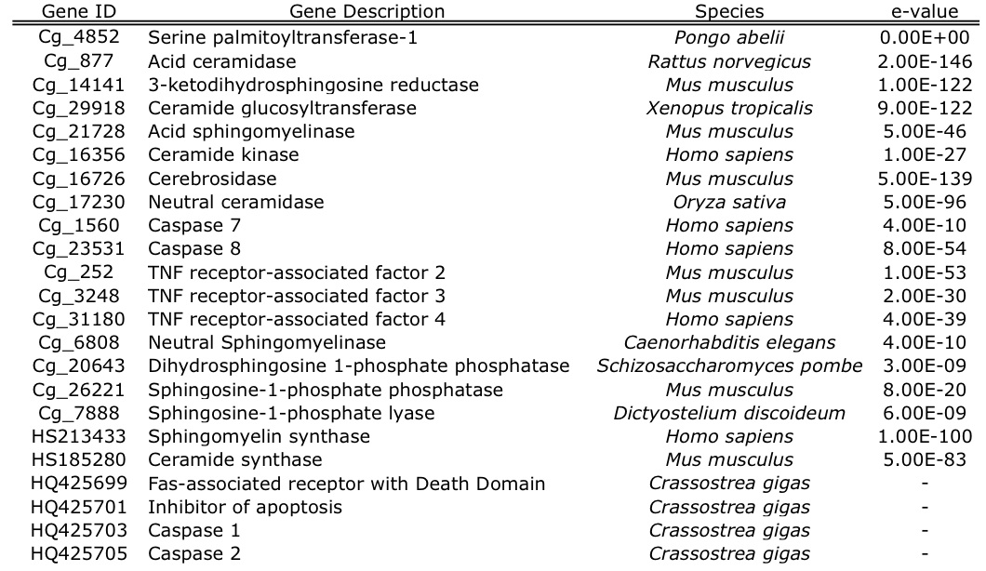
Table 2. Genes associate with ceramide metabolism were identified in C. gigas by searching of publicly available databases. Sequences assembled from short read archive data and expressed sequence tags were given a Gene ID code that corresponds to the sequence in the Appendix (Table A.1). For each of these contiguous sequences, the top BLASTx hit description, corresponding species, and e-value are provided. Two genes that were identified as a single EST (sphingomyelin synthase and ceramide synthase) are denoted with their respective GenBank IDs. An additional four genes (GenBank IDs: HQ425699, HQ425701, HQ425703, and HQ425705) have been previously characterized in C. gigas (Zhang et al. 2011)

FIGURE LEGENDS

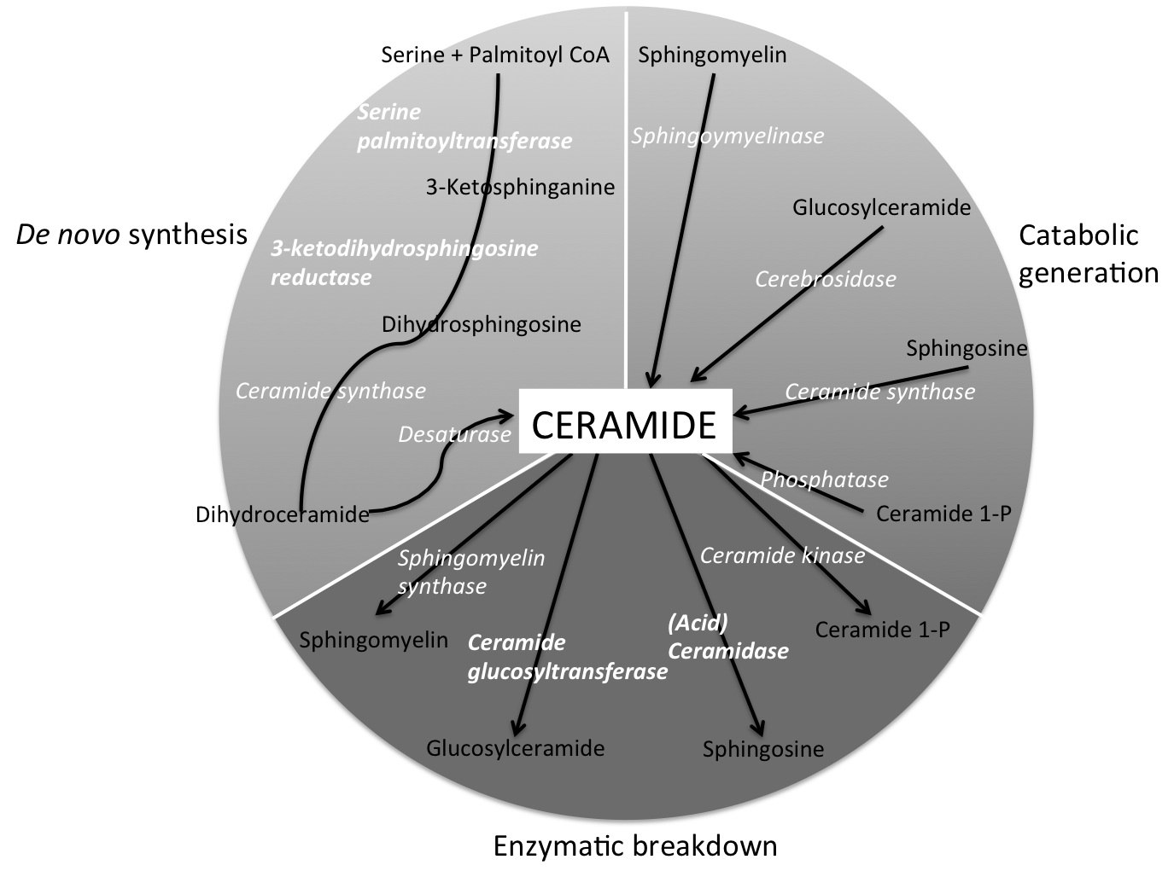
Fig. 1. Representation of the major players in the ceramide metabolism pathways. Enzymes are in white italics with the genes characterized as part of this study in bold: serine palmitoyltransferase, 3-ketodihydrosphingosine reductase, ceramide glucosyltransferase, and acid ceramidase. Compounds that are either precursors, or the products of enzymatic break-down of ceramide, are shown in black. The pathway is adapted from Ballou et al. (1996) and Hannun and Luberto (2000).

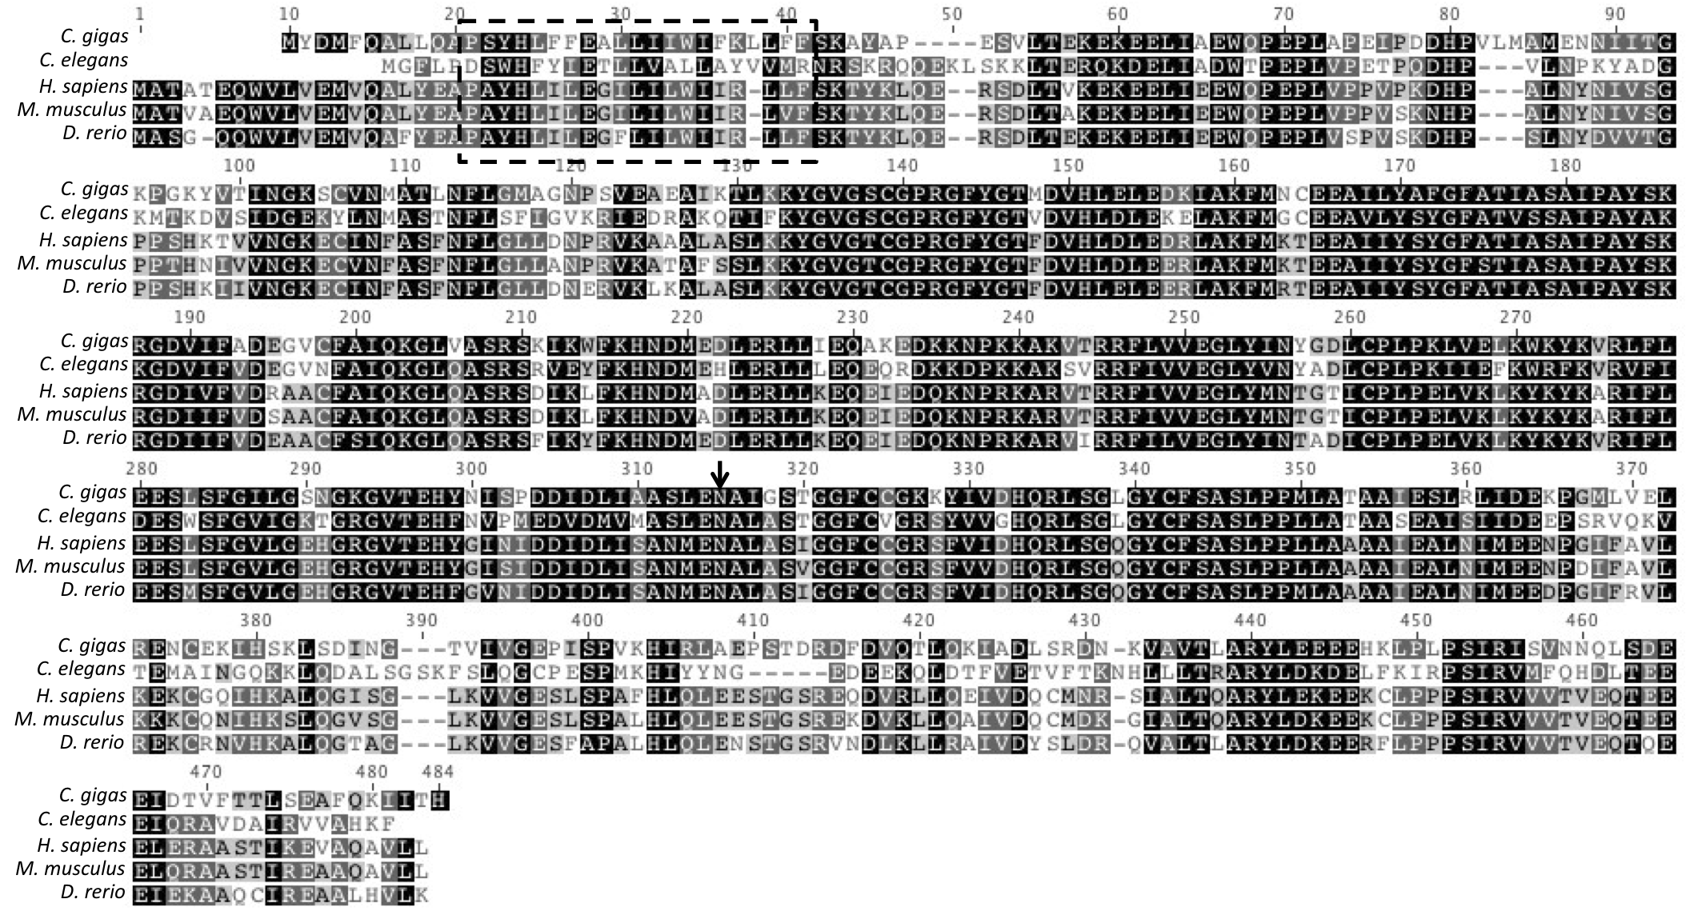
Figure 2. Amino acid alignment of translated Cg-sptlc1 with protein sequence of C. elegans (GenBank ID: NP_001021978 ), H. sapiens (GenBank ID: NP_006406), M. musculus (GenBank ID: NP_033295), and D. rerio (GenBank ID: NP_001018307). Black shading indicates 100% similarity across sequences, dark gray is 80-100% similarity, light gray is 60-80% similarity, and white is less than 60% similarity. The transmembrane domain is marked by the dashed box and the asparagine that corresponds to the H. sapiens LCB1 isoform is marked with an arrow.

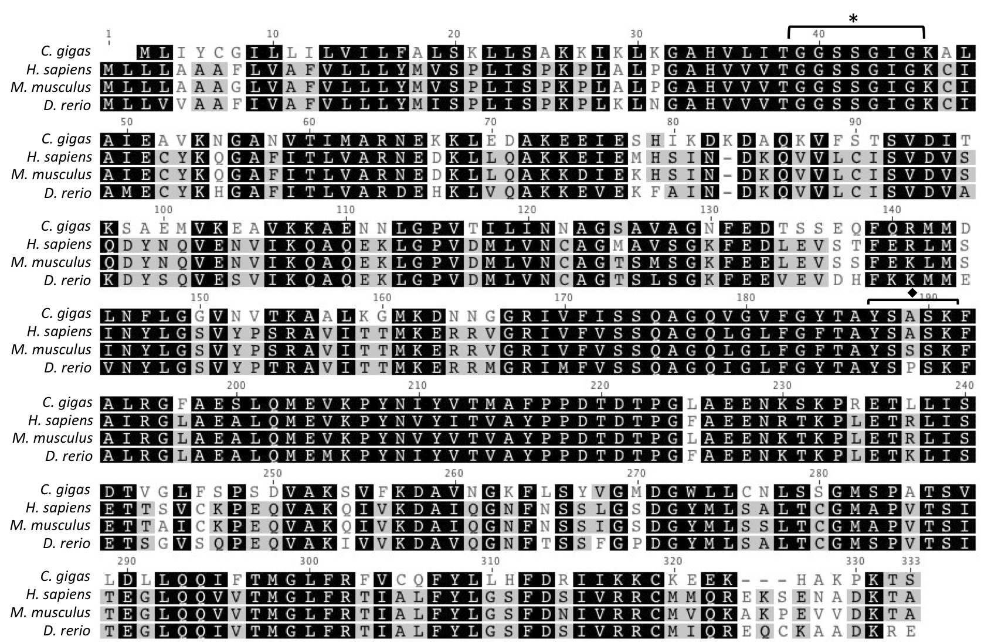
Figure 3. Amino acid alignment of translated Cg-3KDSR with protein sequence from H. sapiens (GenBank ID: Q06136), M. musculus (GenBank ID: NP_081810), and D. rerio (GenBank ID: NP_957433). Black shading indicates 100% similarity across sequences, dark gray is 80-100% similarity, light gray is 60-80% similarity, and white is less than 60% similarity. The conserved catalytic site is marked with an asterisk and the NADH/NADPH binding site and active site motif is marked with a diamond.

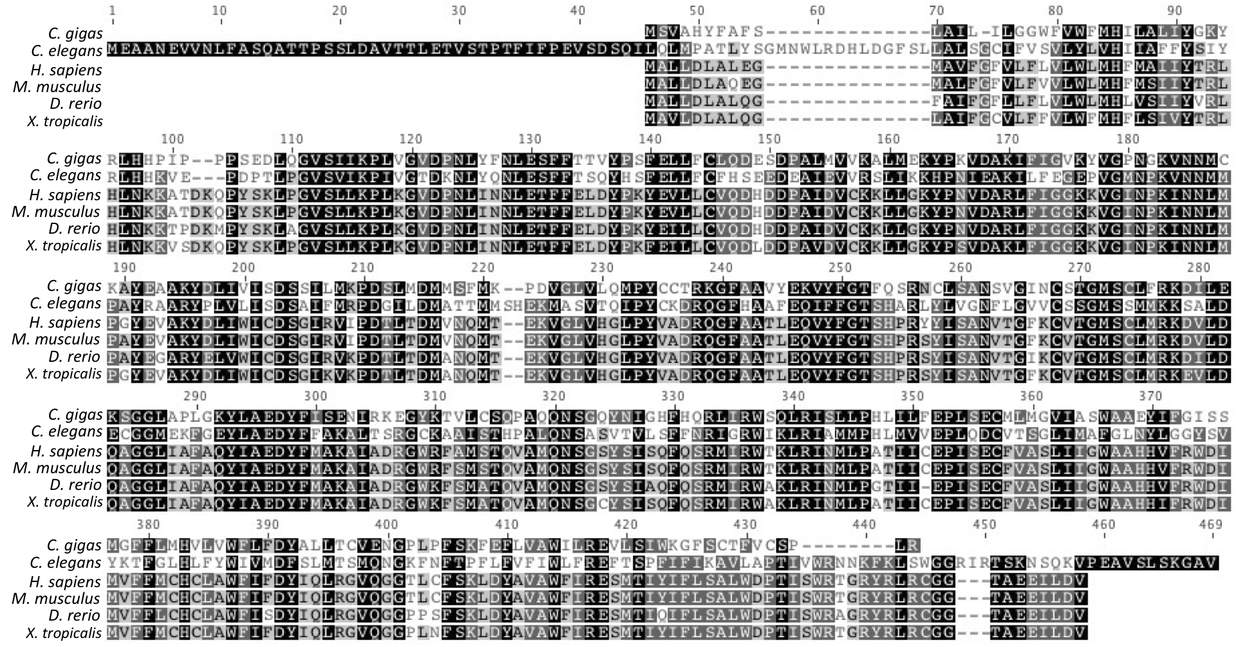
Figure 4. Amino acid alignment of translated Cg-GlcCer with ceramide glucosyltransferase protein sequences from C. elegans (GenBank ID: NP_506971), H. sapiens (GenBank ID: NP_003349), M. musculus (GenBank ID: NP_035803), and X. tropicalis (GenBank ID: Q5BL38). Black shading indicates 100% similarity across sequences, dark gray is 80-100% similarity, light gray is 60-80% similarity, and white is less than 60% similarity.

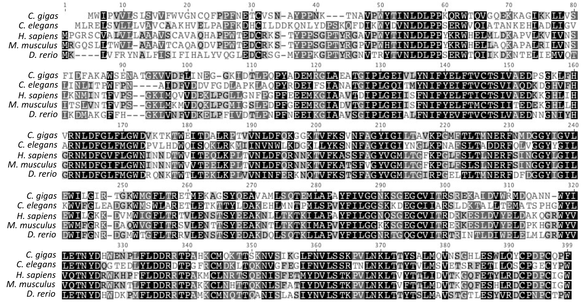
Figure 5. Amino acid alignment of translated Cg-AC with protein sequences from acid ceramidase in C. elegans (GenBank ID: NP_493173), H. sapiens (GenBank ID: NP_808592), M. musculus (GenBank ID: NP_062708), and D. rerio (GenBank ID: NP_001006088). Black shading indicates 100% similarity across sequences, dark gray is 80-100% similarity, light gray is 60-80% similarity, and white is less than 60% similarity.

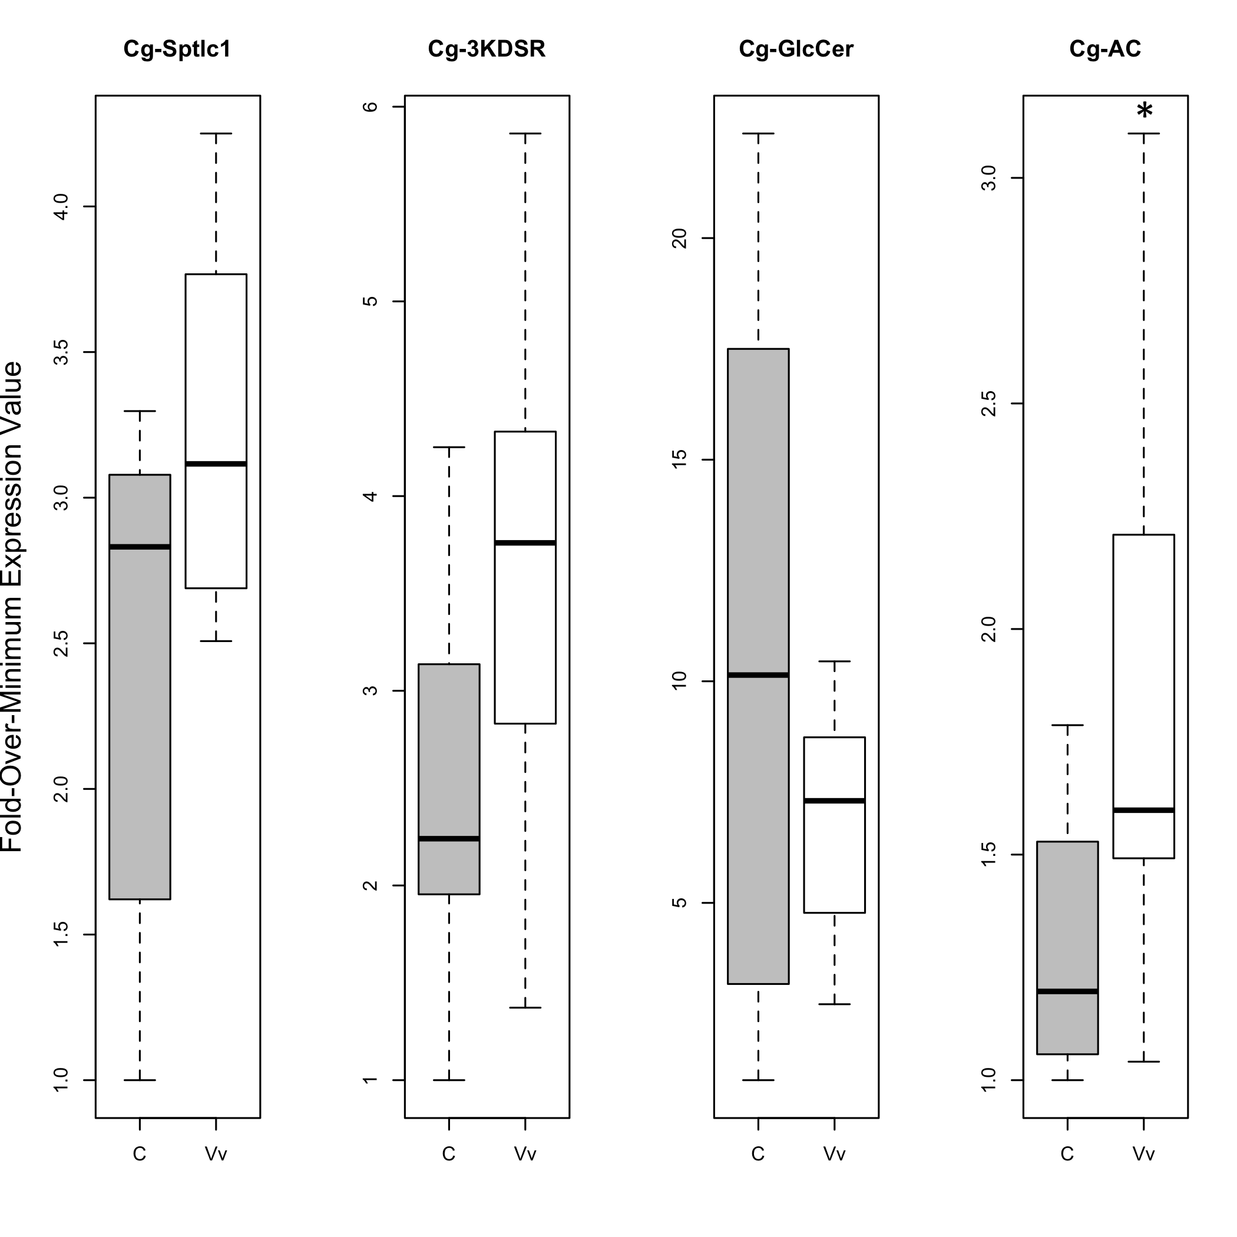
Figure 6. Expression values in gill tissue for serine palmitoyltransferase-1 (Cg-sptlc1), 3-ketodihydrosphingosine reductase (Cg-3KDSR), glucosylceramidase (Cg-GlcCer), and acid ceramidase (Cg-AC) . Gene expression values for the control (“C”) oysters are represented by the gray boxes, while the V. vulnificus-exposed (“Vv”) oysters are represented with the white boxes. Boxes represent the spread of the middle 50% of the data with the median shown as the horizontal black line in the box. The dotted lines span the remaining data. An asterisk indicates a significant difference in expression between exposed and control oysters.

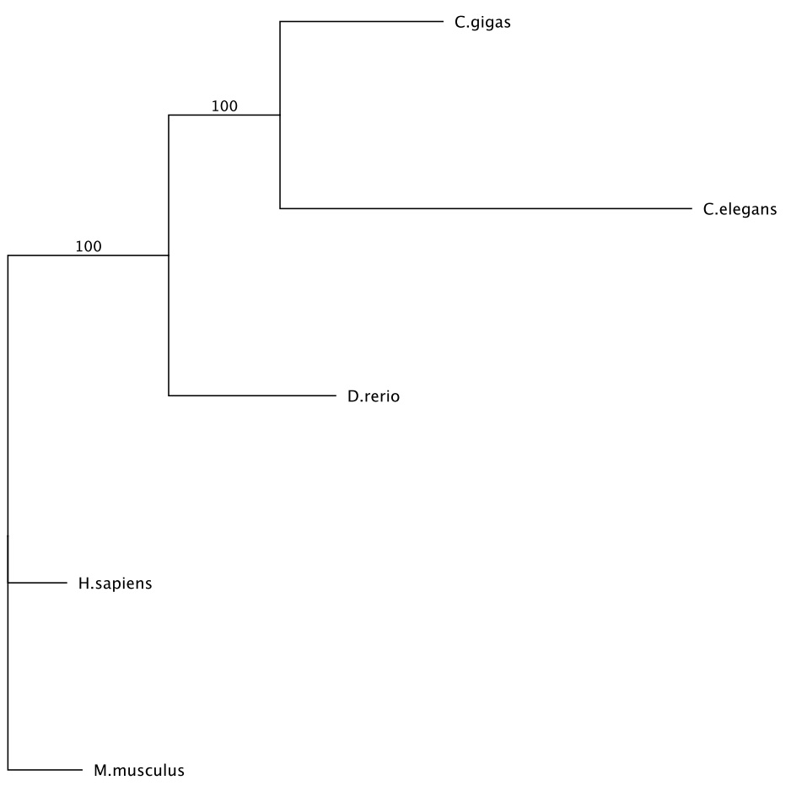
Figure 7. Maximum likelihood phylogenetic tree of the amino acid alignment of acid ceramidase in C. gigas, C. elegans, H. sapiens, M. musculus, and D. rerio. All other protein trees had similar topology to the one shown. The tree was created based on the James-Taylor-Thornton (JTT) model and bootstrapped 100 times.

