Identification of biological process influenced by ocean acidification in manila clam (Ruditapes philippinarum) using transcriptome sequencing and RNAseq analysis

Introduction Outline
Paragraph1

Clams are farmed in several countries around the world and account for a large proportion of total global production of shellfish. Like other shellfish species, manila clams are filter feeders and can impact water quality by feeding on micro algae living in the water column. Changing environmental conditions could potentially alter the survival and production of manila clams and therefore have dramatic impacts both economically and ecologically. Manila
clams are sessile organisms with a planktonic larval period lasting for approximately two weeks before the larvae settle in the intertidal region and burrow into the sediment. Studies on manila clam larvae have documented sensitivity to several common environmental stressors such as temperature, salinity, pathogens, and nutrient deprivation (Inoue et al., 2006; Xiwu et al., 2009; Numaguchi et al., 1998; Paillard et al., 2004). Studies regarding the survival and physiological processes affected by ocean acidification have been documented for larvae in other shellfish species such as oysters. However, there are no reports concerning the impact of decreasing pH and changing carbonate chemistry on R. philippinarum larvae.

Paragraph 2
Ocean acidification as a result of anthropogenic carbon emissions is an immediate concern to the health of calcifying organisms.

Ocean acidification is a global problem that threatens to impact shellfish harvests around the world. Recent reports of larval shellfish mortalities in Puget Sound are cause for concern and more information regarding the impacts this could have on commercial shellfish production is needed.

Dissolved pCO2 concentrations in the ocean are influenced by several natural processes. The phenomenon of ocean acidification is a result of increased carbon emissions from industrial practices that occurs through surface seawater mixing where carbon dioxide from the atmosphere equilibrates with the dissolved CO2 of surface seawater. The equilibrated surface seawater can then be pulled down to the deep ocean where it can incubate for several years under high pressure and low temperature. This water later resurfaces during upwelling events such as those documented off the western coast of the United States. Recent reports have observed pCO2 conditions that exceed 1000ppm in upwelled waters.
Upwelled waters off the western coast of the United States have dissolved inorganic CO2 concentrations exceeding the ambient sea level concentrations of 400ppm (Feely 2008). The aragonite levels of this upwelled water are below 1, which is thought to be the threshold level for which calcifying organisms can properly form carbonate structures (Feely 2008). In addition to the influx of corrosive upwelled waters, the carbonate chemistry of estuaries such as Puget Sound are also affected by normal biological processes such as respiration and the decomposition of organic matter. Increases in anthropogenic CO2 emissions only exacerbate the compounding effects of corrosive upwelled waters and biological processes on dissolved pCO2 and aragonite concentrations. Puget Sound, WA represents one of the most productive shellfish growing regions in the United States. Therefore, characterizing the effects of increased pCO2 on larval survival and physiology is necessary to understand the potential impacts ocean acidification will have on this economically important industry.

Carbonate chemistry in the intertidal region such as tide pools and sediments is extremely variable. Clam larvae settle in these environments and are consequently susceptible to changes in carbonate chemistry and potentially tolerable of wide fluctuations.

Paragraph 3
Advances in genomics have allowed for the sequencing and documentation of transcriptional changes in organisms for which there is little genetic information.
Genomics is a powerful tool to observe functional changes in physiological processes impacted by changing environmental conditions.
Understanding physiological responses at the genetic level can provide valuable insight into mechanisms responsible for mortality or those that are used to tolerate stressful conditions.

Paragraph 4
Previous reports have documented _________ thousand new contigs in clams, however these studies were done in a tissue specific manner on only adult organisms. To date, no studies have looked at characterizing the transcriptome of larval clams, specifically the genes involved in developmental processes and stress response (?).
No studies have used NGS to characterize the transcriptome of clams exposed to different pCO2 levels. Several have used microarray technology, but microarrrays require a priori sequence information and are selectively biased on which contigs are represented on the array.
NGS sequencing is an unbiased approach to characterize the whole transcriptome.

Paragraph5
In this study we characterized the transcriptome of larval Manila clams and the genes that are activated during larval development.
We also characterized changes between the transcriptome of clams exposed to ambient and future pCO2 concentrations.

Materials and Methods

Experimental Design
All Experimental treatments were conducted at NOAA’s Northwest Fisheries Science Center’s (NWFSC) ocean acidification facility in Seattle, WA, which contains multiple, independent recirculating seawater systems each capable of controlling both CO₂ concentration and temperature. Manipulation of dissolved CO₂ concentrations was achieved by bubbling CO₂ into equilibration tanks in which CO₂ level was monitored using a Licor XXX gas analyzer and controlled using Labview software (XXX).. One system was calibrated to maintain near present day (ambient) oceanic sea surface levels of pCO2 (400ppm) and the second system was calibrated to reflect acidified conditions experienced under a higher projected level of pCO₂ concentration (1000ppm). Spectrophotomectric pH was measured on sampling days (listed below) in larval chambers within each system; water samples for total alkalinity and dissolved inorganic carbon were taken on days 3, 5, and 12 and analyzed at the NOAA Pacific Marine Environmental Laboratory (PMEL). Seawater (~30 psu) was collected from Elliot Bay, Seattle, WA, filtered to XX µm, and maintained at 18ºC for the duration of the study.
Venerupis (=Ruditapes) philippinarum (R. philippinarum) larvae were obtained from the Taylor Shellfish Hatchery in Kona, Hawaii. Larvae were evenly distributed in twelve 4.5L CO₂ impermeable seawater chambers at a density of approximately 11 larvae/mL (48,600 larvae/chamber). Larval chambers were placed in the appropriate recirculating seawater treatment system (6 chambers/treatment) and each received an average flow rate of 3L/hour for the duration of the experiment. Larval clams were fed a mixture of algae (Nannochloris sp., Chaetoceros muelleri, Isochrysis galbana, and Pavlova lutherii) twice daily at a final concentration of 50,000-80,000 cells/ml. Algae was cultured at the Taylor Shellfish Hatchery. Chambers were cleaned on a semi-weekly schedule that coincided with sampling. .

Larval mortality and size analysis
On days 1, 4, 7, 11, and 14 three larval chambers from each treatment were sampled for mortality and size analysis. Larvae were isolated on a 50um screen and transferred to a 50mL tube where two replicate samples of ~50 larvae each were transferred into a 12 well plate. Consecutive sampling of jars between sampling days was avoided to maintain similar larval densities between replicates. Larval mortality was determined by counting the number of dead larvae using an inverted compound microscope at 20x magnification (scope manufacturer?). Subsequently 75% EtOH was added to immobilize live larvae to quantify the total number of larvae per well. Larval size was determined by analyzing photographs taken at 5x magnification with a __________ camera. Total surface area for each larva was calculated using ImageJ. Data collected from replicate samples within a chamber were averaged.

Larvae RNA Isolation
Samples for RNA isolation were taken on day 7 from two chambers in each treatment by isolating larvae on a 50 μm screen. Samples for RNA extraction consisted of ~30,000 larvae from each larval chamber. RNA was isolated using Tri-reagent (Molecular Research Center, Inc., city, state, country) following the manufacturer's protocol. Equal quantities of total RNA (20µg) from each replicate were pooled in equal quantity to generate two libraries.

Illumina sequence data processing and identification of novel genes
Library construction and sequencing was performed at the University of Washington High Throughput Genomics Unit (UWHTGU) on the Illumina Hi-seq platform (Illumina inc., San Diego, CA) using standard protocols. CLC Genomics Workbench version 4.0 (CLC bio) was used for sequence analysis. Initially, sequences were trimmed based on a quality scores of 0.05 (Phred; Ewing, Green, 1998; Ewing et al., 1998) and the number of ambiguous nucleotides (>2 on ends). Sequences smaller than 25 bp were also removed.

For gene discovery and RNA-seq analysis, sequences from in the National Center for Biotechnology Information (NCBI) short read archive (SRA) from R.philippinarum digestive gland tissue (SRX022422; Milan et al., 2011) and gonad (SRX076440-SRX076463; Ghiselli et al., 2011) were de novo assembled together with sequences from the R. philippinarum transcriptome database (RUPHIbase; http://compgen.bio.unipd.it/ruphibase/). De novo assembly parameters were as follows: limit=8, mismatch cost=2, and minimum contiguous sequence (contig) size of 200 bp. A reference assembly of reads from the ambient and high treatment Illumina sequencing libraries was then performed using the contigs from the previous de novo assembly as a backbone. A separate file of unmapped reads was generated from the reference assembly. Unmapped reads were then de novo assembled using the same conditions as previously described.

Contigs from de novo assembly of the unmapped reads was compared to the Swiss-Prot database (http://uniprot.org) to obtain putative sequence identification. Comparisons were made using the BLASTx algorithm (Altschul et al., 1997) with an e-value cutoff of 1e⁻³. Annotated sequences were paired with their associated GO terms (Gene Ontology database; http://www.geneontology.org) for characterization of genes based on biological processes and to group consensus sequences into parent terms (GO_slim).

RNA-Seq expression analysis
RNA-Seq analysis was carried out to determine differential gene expression patterns between the two libraries. Using the same de novo assembly parameters as described above, sequences from the digestive gland, gonads, and RUPHIbase were combined with the libraries from the ambient and high pCO2 treatments to generate a list of contigs that were used as a backbone. RNA-seq analysis was performed using the following parameters were used for analysis; unspecific match limit = 10, maximum number of mismatches = 2, minimum number of reads = 10. Expression values were measured in RPKM (reads per kilobase of exon model per million mapped reads; see Mortazavi et al., 2008). Differentially expressed genes were identified as having > 2 fold change in RPKM expression values. Significance was determined using a Baggerley test (Baggerly et al., 2003) with a 0.05 level of significance.
Analysis of significantly enriched GO terms from differentially expressed genes was conducted using the Database for Annotation, Visualization, and Integrated Discovery (DAVID) v.6.7 (http://david.abcc.ncifcrf.gov/) (Huang et al., 2009a; Huang et al., 2009b). Contigs identified as differentially expressed by RNA-Seq analysis with a calculated e-value of 1e⁻³ by BLASTx were used as a gene list while all contigs from the de novo assembly with e-vales no more than 1e⁻³ were used as the background. Significantly enriched GO terms were identified by Benjamini-Hochberg method (Benjamini and Hochberg, 1995) for calculating the false discover rate for multiple comparisons (p<0.05). Significantly enriched GO terms and their associated p-vales from DAVID were uploaded to REViGO (Reduce + Visualize Gene Ontology http://revigo.irb.hr/) for spatial visualization. Swiss-Prot accession numbers for significantly enriched GO terms were extracted for further analysis.

Results

Water Chemistry
Water treatment conditions for ambient and elevated pCO2 equilibrated water are summarized in Table 1. Ambient conditions were maintained at 355.04 μatm +/- 16.85 with a pH of 8.07 +/- .02. These values are consistent with the current sea surface pCO2 conditions. The elevated conditions maintained pCO2 levels of 897 μatm +/- 47.61SD with a pH of 7.71 +/- .02SD which is representative of projected sea surface conditions but is also similar to pCO2 conditions in areas influenced by upwelling events such as those found in hood canal and Puget Sound, WA. Manipulation of pCO2 conditions was efficient in driving down the saturation state of aragonite and calcite. Aragonite levels dropped from 3.63 in the ambient treatment to 1.12 in the elevated pCO2 treatment, a value just above the critical saturation level for calcification of 1. Similarly, the concentration of calcite decreased from 3.63 in ambient to 1.76 in the elevated pCO2 treatment.

Table1
Summary of water chemistry measurements for ambient and elevated pCO2 treatments +SD

Larval growth and survival
There was no detectable effect of elevated pCO2 conditions on R. philippinarum growth and survival (figure x). Larval shell size increased steadily in both treatments over the course of the experiment. Larval survival was not statistically different between treatments, however there was a slight trend of increased survival in the elevated pCO2 conditions. There was also a trend from days one through seven where larvae in ambient pCO2 conditions appear to be growing at a faster rate but the trend diminishes by day 11.
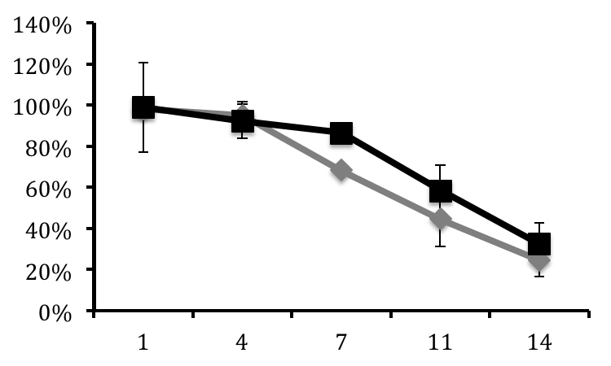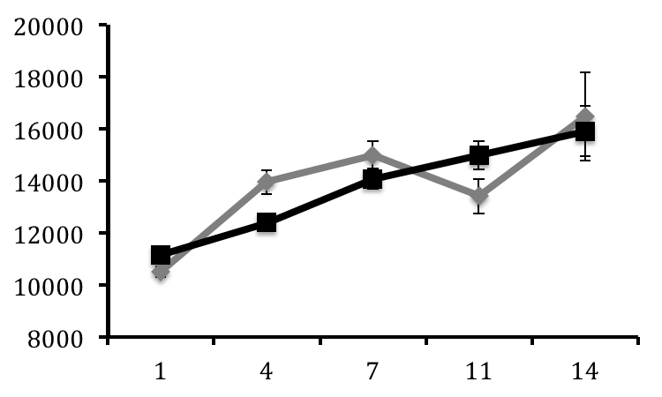

Figure 3
Percent larval survival at ambient (diamonds) and high (triangles) pCO2 conditions on days 1, 4, 7, 11, and 14 +/- SE (n=3/day).

Illumina Sequencing

Sequencing of the R.philippinarum larval transcriptome yielded a total of 175,724,967 and 68,062,722 reads from the ambient and acidified libraries, respectively. All data are available in the NCBI Short Read Archive database (Accession # XXXXXX). After quality trimming, 146,019,873 and 67,691,220 reads remained from the ambient and acidified libraries, respectively, with an overall average length of 36 bp.

RNAseq analysis
Expression analysis by RNAseq resulted in 57,985,294 (39.7%) reads from the ambient transcriptome library, and 26,075,212 (38.5%) reads from elevated pCO2 transcriptome library mapping to the 32,606 contigs from the RUPHIbase transcriptome database. Among the reads from the ambient library that mapped, 47,210,547 (81.4%) mapped to a single contig while 19,397,495 reads (74.4%) from the elevated pCO2 treatment library mapped to a single contig. Among the contigs identified in the ambient and elevated pCO2 libraries, 781 contigs were differentially regulated with a fold change >1.5 (p<0.1) (Supplemental Table 1). Analysis of significantly enriched GO terms from the population of significantly regulated contigs revealed 116 unique biological processes among which are purine nucleotide transport, protein targeting, ATP synthesis coupled proton transport, rRNA processing, gene expression, translation, positive regulation of nitric oxide biosynthesis, retinoic acid metabolism, erythrocyte homeostasis, mitotic cell cycle G1/S transition checkpoint, ER-associated protein catabolism, microtubule-based process, hydrogen peroxide catabolism, embryo development, reproduction, respiratory electron transport chain, and microtubule-based movement (Figure X). The genes associated with these biological processes are highlighted (*) in supplemental table 1.

Of particular interest to this study are genes involved in calcification and proton transport. While not identified as an enriched biological process, Perlucin-6, a gene involved in nucleation of calcium carbonate ions during shell formation, was significantly elevated (133 fold) in the high pCO2 treament library. Interestingly, genes that are involved in several vital cellular processes that rely on calcium binding activity to function properly were also induced in the larvae exposed to elevated pCO2 conditions. These genes include calmodulin, calreticulin, proteins containing EF-hand motifs such as sarcoplasmic calcium-binding protein and the calcium-binding ef-hand domain protein, myosin alkali light chain 1, and voltage-dependent anion channel 1.

While stress response was not identified as a biological process that is significantly regulated, genes involved in stress response are of interest when monitoring physiological changes to environmental stress. Molecular chaperones heat shock protein 70 and 90 are commonly used as indicators of stress and both are induced in the larvae exposed to elevated pCO2. Genes involved in response to oxidative stress, including thioredoxin and glutathione peroxidase 3 were also observed to be induced in larvae exposed to elevated pCO2.

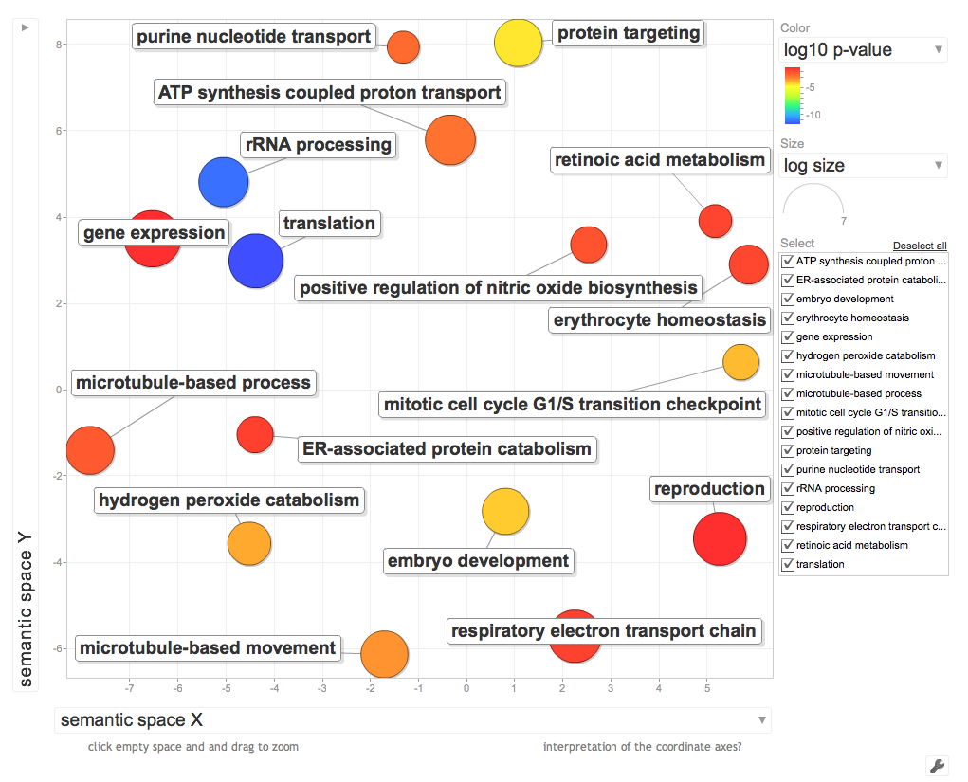

Figure 3
Visualization of enriched GO processes identified from significantly regulated genes. Distance between processes represents relatedness while size of the circles is represents –log10 p-value of the GO term enrichment.

Discussion Outline

Paragraph 1
No difference in growth and mortality.
Why?
Why not?

Process “A” that’s affected
What is it, what does it do?
Similar or dissimilar to what other people found?

Process “B” that’s affected
What is it, what does it do?
Similar or dissimilar to what other people found?

Interesting Genes outside of GO processes
Percolin 6
Genes that can be used in future studies.

References
Altschul, S. F., Madden, T. L., Schaffer, A. A., Zhang, J., Zhang, Z., Miller, W., & Lipman, D. J. (1997).
Gapped BLAST and PSI-BLAST: A new generation of protein database search programs.
Nucl. Acids Res., 25, 3389-3402.
Available at http://www.ncbi.nlm.nih.gov/BLAST/.

Benjamini, Yoav; Hochberg, Yosef (1995). "Controlling the false discovery rate: a practical and powerful approach to multiple testing". Journal of the Royal Statistical Society, Series B (Methodological) 57 (1): 289–300. MR1325392.

Huang DW, Sherman BT, Lempicki RA. Systematic and integrative analysis of large gene lists using DAVID Bioinformatics Resources. Nature Protoc. 2009;4(1):44-57.
Huang DW, Sherman BT, Lempicki RA. Bioinformatics enrichment tools: paths toward the
comprehensive functional analysis of large gene lists. Nucleic Acids Res. 2009;37(1):1-13.

Figures

