TITLE: RNA-seq uncovers physiological impact of ocean acidification on manila clam (Ruditapes philippinarum) larvae

AUTHORS:

ABSTRACT:

Introduction Outline

Manila
clams are benthic bivalve molluscs with planktonic larval period lasting for approximately two weeks before the larvae settle in the intertidal region and burrow into the sediment. Studies on manila clam larvae have documented sensitivity to several environmental stressors such as temperature, salinity, pathogens, and food availability (Inoue et al., 2006; Xiwu et al., 2009; Numaguchi et al., 1998; Paillard et al., 2004). To date, there are no reports concerning the impact ocean acidification on R. philippinarum larvae.

Ocean acidification is a result of elevated atmospheric pCO2 and natural process resulting in
decreased pH and altered carbonate chemistry (Reference). These changes in carbonate chemistry have been shown to be particulary deterimental to calcifying organisms such as bivalve molluscs.

SENTENCE ON HOW SHELLS ARE IMPACTED> Recent reports have observed pCO2 conditions that exceed 1000ppm in upwelled waters.
Upwelled waters off the western coast of the United States have dissolved inorganic CO2 concentrations exceeding the ambient sea level concentrations of 400ppm (Feely 2008). The aragonite levels of this upwelled water are below 1, which is thought to be the threshold level for which calcifying organisms can properly form carbonate structures (Feely 2008). In addition to the influx of corrosive upwelled waters, the carbonate chemistry of estuaries such as Puget Sound are also affected by normal biological processes such as respiration and the decomposition of organic matter (ref). I

While a majority of impacts have been classified as negative, there is some variablabilty in the impact of larvae. .…
Much of the characteriztions have focus on morphology, developement and survival. There are some studies that have explored impacts at the gene and protein level.
summary

In this study we characterized the transcriptome of larval Manila clams and the genes that are activated during larval development.
We also characterized changes between the transcriptome of clams exposed to ambient and future pCO2 concentrations.

Materials and Methods

Experimental Design
All experimental treatments were conducted at the NOAA’ Northwest Fisheries Science Center (NWFSC) in Seattle, WA. Manipulation of dissolved CO₂ concentrations was achieved by the addition of CO₂ into two independent reservoirs with CO₂ levels monitored using a Licor XXX gas analyzer and controlled using Labview software (XXX). One system maintained near present day (ambient) oceanic sea surface levels of pCO2 (400 μatm) and the second system maintained an elevated pCO₂ concentration (1000 μatm) to represent acidified conditions. Spectrophotomectric pH was measured on each sampling day in larval chambers within each system. Water samples for total alkalinity and dissolved inorganic carbon were taken on days 3, 5, and 12 and analyzed at the NOAA Pacific Marine Environmental Laboratory (PMEL). Seawater (~30 psu) was collected from Elliot Bay, Seattle, WA, filtered to XX µm, and maintained at 18ºC for the duration of the study.
Ruditapes philippinarum larvae were obtained from Taylor Shellfish in Kona, Hawaii. Larvae were evenly distributed in twelve 4.5L CO₂ impermeable chambers at a density of approximately 11 larvae/mL (48,600 larvae/chamber). Larval chambers were placed in the appropriate recirculating seawater treatment system (6 chambers/treatment). Average flow rate for the experiment was 3L/hour. Larval clams were fed a mixture of algae (Nannochloris sp., Chaetoceros muelleri, Isochrysis galbana, and Pavlova lutherii) twice daily at a final concentration of 50,000-80,000 cells/ml. Chambers were cleaned on a semi-weekly schedule that coincided with sampling.

Larval mortality and size analysis
On days 1, 4, 7, 11, and 14 three larval chambers from each treatment were sampled for mortality and size analysis. Larvae were isolated on a 50um screen and two replicate samples of ~50 larvae each were transferred into a 12 well plate. Consecutive sampling of jars between sampling days was avoided to maintain similar larval densities between replicates. Larval mortality was determined by counting the number of dead larvae using an inverted compound microscope at 20x magnification (manufacturer). Subsequently 75% EtOH was added to immobilize live larvae to quantify the total number of larvae per well. Larval size was determined by analyzing photographs taken at 5x magnification with a __________ camera. Total surface area for each larva was calculated using ImageJ. Data collected from replicate samples within a chamber were averaged. Stats

Larvae RNA Isolation
Samples for RNA isolation were taken on day 7 from two chambers in each treatment by isolating larvae on a 50 μm screen. Samples for RNA extraction consisted of ~30,000 larvae from each larval chamber. RNA was isolated using Tri-reagent (Molecular Research Center, Inc) following manufacturer protocols. Equal quantities of total RNA (20µg) from each replicate were pooled in equal quantity for the construction of two transcriptome libraries.

High-throughput sequencing
Library construction and sequencing was performed at the University of Washington High Throughput Genomics Unit (UWHTGU) on the Illumina Hi-seq platform (Illumina inc., San Diego, CA) using standard protocols. CLC Genomics Workbench version 4.0 (CLC bio) was used for all sequence analysis. Initially, sequences were trimmed based on a quality scores of 0.05 (Phred; Ewing, Green, 1998; Ewing et al., 1998) and the number of ambiguous nucleotides (>2 on ends). Sequences smaller than 25 bp were also removed.

RNA-Seq analysis
RNA-Seq analysis was carried out to determine differential gene expression patterns between the two libraries. For RNA-seq analysis RuphiBase, the Manila Clam (Ruditapes philippinarum) transcriptome database (http://compgen.bio.unipd.it/ruphibase/) was used as the reference transcriptome. At the time of analysis this database consisted of 32,606 contiguous sequences (contigs) generated from 454 (Roche) reads (Reference), 5656 Sanger ESTs, and 51 publicly available mRNA sequences. Contigs in RuphiBase are annotated by Gene Ontology and protein (NCBI nr database) BLAST results. RNA-seq analysis was performed using the following parameters; unspecific match limit = 10, maximum number of mismatches = 2, minimum number of reads = 10. Expression values were measured in RPKM (reads per kilobase of exon model per million mapped reads; see Mortazavi et al., 2008). Differentially expressed genes were identified as having > 1.5 fold change between libraries and a p-value <0.10 (Baggerly et al., 2003). Hypergeometric tests on annotations was performed to identify enriched biological themes in the differentially expressed genes as compared to the whole transcriptome. This test procedure was performed using CLC Genomics Workbench V4.0 and is similar to the unconditional GOstats test of Falcon and Gentleman, 2007. Significantly enriched (p<0.10) GO terms and their associated p-values were uploaded to REViGO (Reduce + Visualize Gene Ontology http://revigo.irb.hr/) for visualization.

Results
Water Chemistry
Ambient conditions were maintained at 355.04 μatm +/- 16.85 with a pH of 8.07 +/- .02. The elevated treatment maintained a pCO2 levels of 897 μatm +/- 47.61SD with a pH of 7.71 +/- .02SD. Aragonite levels dropped from 3.63 in the ambient treatment to 1.12 in the elevated pCO2 treatment,. Similarly, the concentration of calcite decreased from 3.63 in ambient to 1.76 in the elevated pCO2 treatment. All water chemistry parameter for both the ambient and elevated treatment are found in Table 1.

Table1
Summary of water chemistry measurements for ambient and elevated pCO2 treatments. Values are expressed as means + standard deviations.

Larval growth and survival
There was no detectable effect of elevated pCO2 conditions on R. philippinarum growth and survival (figure x). Larval shell size increased steadily in both treatments over the course of the experiment.
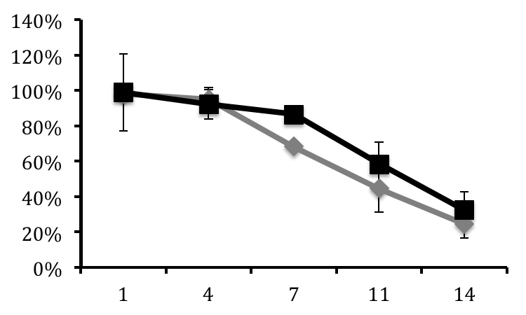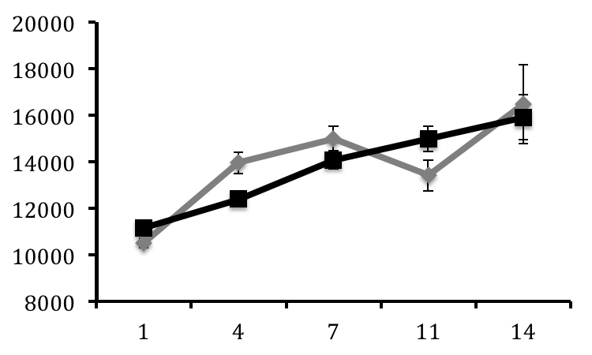

Figure 1
Percent larval survival at ambient (diamonds) and high (squres) pCO2 conditions on days 1, 4, 7, 11, and 14 +/- SE (n=3/day).

RNA-Seq analysis
After quality trimming, 240 million sequence reads (average length: 36 bp) remained from the combined libraries, All data are available in the NCBI Short Read Archive database (Sample ID: SRS283130). RNA-Seq using Ruphibase as the scaffold identifiied 3954 differentially expressed contigs. Of those, 162 contigs were expressed at a lower level on the library constructed form larvae exposed to high pCO2 conditions, and 3792 were expressed at higher level. A subset (779) of the differentially expressed contigs were annotated in Ruphibase (Supplementary Table). Hypergeometric tests on annotations revealed 55 Biological Processes to be significantly enriched in the differentially expressed gene set. . The most significantly enriched processes were associated with translation followed by embryo development and hydrogen peroxide catabolism (Figure x),. Other enriched process included, ATP synthesis coupled proton transport and respiratory electron transport chain and (Figure X). The contigs corresponding with these biological processes are highlighted (*) in Supplemental table 1.

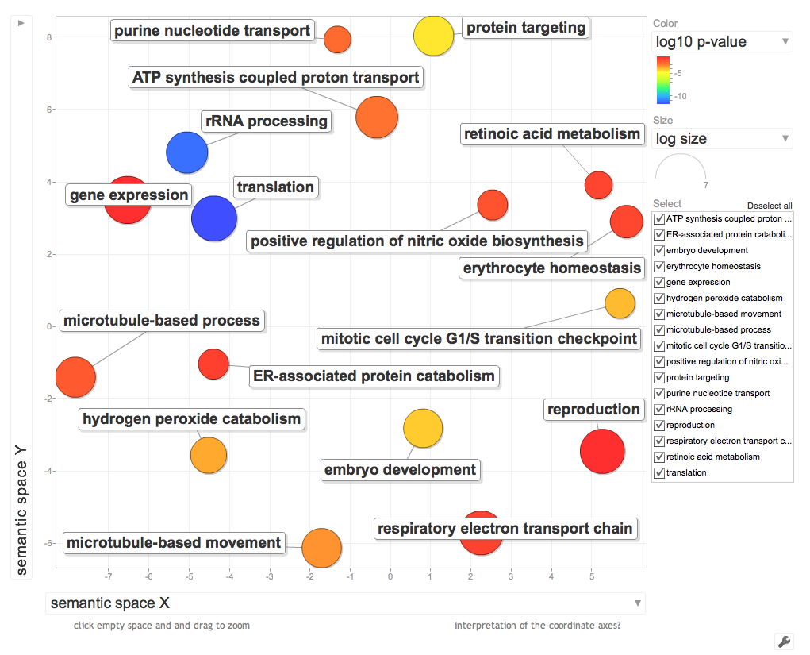

Figure 2
Visualization of enriched GO processes identified from significantly regulated genes. Distance between processes represents relatedness while size of the circles is represents –log10 p-value of the GO term enrichment.

Discussion

Increased dissolution rates of atmospheric carbon dioxide compounded by natural processes such as coastal upwelling and estuarine runoff are contributing to dramatic changes in estuarine water chemistry. Resulting conditions could be potentially devastating to communities of calcifying organisms. While there have been a number of studies on the effects of increased pCO2 on shellfish, there are limited studies where influences on the entire transcriptome have been this. To our knowledge this is the first application of high throughput sequencing technology to evaluate the physiological effects elevated pCO2 conditions in shellfish. A number of biological process were identified as influenced by elevated pCO2 while we did not observe any impact on larval growth and mortality, These combined results provide important information on how shellfish respond to ocean acidification and provide important insight into the variable responses across species.

Examination of R. phillipinarum larvae in this study showed affect of increased pCO2 concentrations on growth and survival. These results are consistent with a recent study in the juvenile clam Ruditapes decussatus where no difference in growth was observed in reduced pH environments (Range et al., 2011). Likewise, no mortality in juvenile R. decussatus was reported (Range et al., 2011). These results are in contrasts to a majority of other studies in bivalves where it has been shown that ocean acidification affects the survival (Fabry et al., 2008; Raven et al., 2005). For instance in the hard clam Mercenaria mercenaria elevated decreased pH resulted in decreased larval survival and shell thickness (Talmage & Gobler, 2009). Decreases in survival may be a results of reduced growth rates (Michaelidis et al., 2005; Berge et al., 2006). Decreased growth rates of bivalve larvae can be attributed to the impaired ability to form shells when aragonite and calcite concentration are below and near the lower saturation limit for calcification thus reducing the calcification rates in these organisms (Orr et al., 2005; Gazeau et al., 2007; McDonald et al., 2009; Miller et al., 2009). Reduced survival can also be attributed to reduced respiration rates ( Michaelidis et al., 2005) the results of which could reduce the cellular metabolism and the production of ATP as a result of a shift in energy resources from essential physiological processes to those under immediate strain from changes in carbonate chemistry such as calcification. Bivalves, however, are thought to be more tolerant of acidifying ocean conditions (Hendriks et al., 2010). It should be pointed out that the organisms used in this study were exposed to an acute change in carbonate chemistry at a state in which they were fully calcified. Analysis of fertilization rates and the immediate survival after fertilization may not coincide with the results presented in this study. These data do suggest that the impact of transient exposure to acidified water by planktonic larvae would not significantly impact manila clam larvae

While no impact on growth or survival during this trial, differential gene expression patterns were identified by RNA-Seq analysis. Overall a majority of the diffrentially expressed genes were upregulated in larvae exposed to elavated pCO2 and the most signficantly enriched biological process were associated with translation and ribosomal activity.

Another biological process that was found to be enriched in the suite of differentially expressed genes was ATP coupled proton transport. It has been hypothesized that regulation of extracellular acid-base balance can determine a species’ tolerance to elevated CO2 (Widdicombe & Spicer, 2008). Specific genes found to be upregulated under elevated pCO2 include XXXXXXXXXXXXXX. These produsct are involved in several vital biological processes such as the generation of ATP, maintenance of hemolymph pH (Byrne & Dietz, 1997), and regulation of ion concentrations involved in calcification (McConnaughey & Gilikin, 2008). Synthesis of ATP is vital for proper function of essential physiological processes. Increased expression of H+ tranport ATP synthase subunits could lead to an increase in ATP production and thus provide the energy needed to compensate for increased demand from the shift in maintenance activities to calcification and growth thought to be responsible for increased mortality in acidified conditions (Widdicombe & Spicer 2008). These molecules are also involved in the regulation ion transport such as calcium. Increases could be indicative of the organism increasing Ca+ scavenging efforts as a result of decreases in calcite concentrations. Similarly, other compounds such as calmodulin are involved in scavenging and detecting Ca+ ions. Calmodulin is known to be involved in Ca+ metabolism and calicification in bivalves (Li et al., 2005). Calmodulin is regulated by G protein beta-subunit, both of which are expressed higher in larvae exposed to elevated CO2. Further evidence to support the theory that manila clam larvae are able to effectively compensate for the decreased availability of calcium carbonate was the 133-fold increase in Perlucin -6 in larvae exposed to elevated pCo2. Perlucin-6, a gene involved in nucleation of calcium carbonate ions during shell formation (REFERENCE). While more effort is needed to illustrate the concerted regulation of these compounds, transcriptomic analysis provides a powerful approach to begin to tease apart the regulatory pathways that are responsible for an organisms ability to tolerate stressful conditions.

Currently there is little information regarding the transcriptome level processes altered by increased CO2 conditions in larval shellfish. Studies to date have focused on candidate genes that are thought to be predicted to be important components of processes such as calcification and metabolism. While these are likely affected, it is unclear what the genetic regulatory mechanism is that is responsible for these changes. Taking a candidate gene approach is not the most effective strategy in this case and a more unbiased transcriptome wide approach is necessary. Studies have been conducted using available microarrays for some of the more commonly studied calcifying marine invertebrates such as sea urchins. While this approach provides a lot of useful information and valuable insights into molecular processes affected by increase CO2, microarrays are inherently biased based on the number available ESTs for a particular species making this approach more suitable for more well studied model systems. Recently, studies have been published that utilized next generation sequencing technologies to characterize the transcritpome of R. philippinarum in adult tissues and the establishment of a transcriptome database for the species. However, no work has been done to sequence and characterize the larval transcriptome. This study illustrates the first documentation of the larval transcriptome in manila clam as well as the first characterization of a transcriptome of an organism exposed to increased CO2 conditions. While there has been a surge in the amount of genomic material available for this species, the power of this approach is that no previous knowledge genomic information is required to extract valuable information and similar studies are possible and necessary in other organisms to understand how physiological response to high CO2 differ between species.

In addition to characterizing the transcriptomic response and the associated physiological process of R. philippinarum larvae to increased CO2 conditions, this study also illustrates that while standard morphometric and survival analysis might indicate tolerance to environmental stresses, characterizing the underlying molecular response can reveal other processes that apparent by other experimental means.

Some nod near the end to acknowledge developemental genes

Shift from

Calcifying species may be at increased risk compared to non calcifying ( Orr et al., 2005; Raven et al., 2005; Gaqeau et al., 2007).

Early life staged are more sensitive (Widdicombe & Spicer 2008).

