GET DATA /TYPE=XLSX
/FILE='/Users/srlab/Dropbox/Lab/Dave/OA Clam NGS/filtered_1000ppm_ACTTGA_L002_R1 trimmed mapping (16962 references).xlsx'
/SHEET=name 'filtered_1000ppm_ACTTGA_L00...'
/CELLRANGE=full
/READNAMES=on
/ASSUMEDSTRWIDTH=32767.
EXECUTE.

Error # 105. Command name: EXECUTE
This command is not valid before a working file has been defined.
Execution of this command stops.
DATASET NAME DataSet1 WINDOW=FRONT.

GET DATA
/TYPE=TXT
/FILE="/Users/srlab/Dropbox/Lab/Dave/OA Clam NGS/filtered_1000ppm_ACTTGA_L002_R1 trimmed mapping (16962 references).txt"
/DELCASE=LINE
/DELIMITERS="\t "
/ARRANGEMENT=DELIMITED
/FIRSTCASE=1
/IMPORTCASE=ALL
/VARIABLES=
V1 A6
V2 A6
V3 A4
V4 A9
V5 A11
V6 A6
V7 A2
V8 A5
V9 A7
V10 A8.
CACHE.
EXECUTE.
DATASET NAME DataSet2 WINDOW=FRONT.

GET DATA
/TYPE=TXT
/FILE="/Users/srlab/Dropbox/Lab/Dave/OA Clam NGS/filtered_1000ppm_ACTTGA_L002_R1 trimmed mapping (16962 references).txt"
/DELCASE=LINE
/DELIMITERS="\t"
/ARRANGEMENT=DELIMITED
/FIRSTCASE=2
/IMPORTCASE=ALL
/VARIABLES=
Name A10
Lengthofconsensussequence F4.0
Numberofreads F5.0
Averagecoverage F11.8.
CACHE.
EXECUTE.
DATASET NAME DataSet3 WINDOW=FRONT.
DATASET CLOSE DataSet2.
* Chart Builder.
GGRAPH
/GRAPHDATASET NAME="graphdataset" VARIABLES=Lengthofconsensussequence MISSING=LISTWISE REPORTMISSING=NO
/GRAPHSPEC SOURCE=INLINE.
BEGIN GPL
SOURCE: s=userSource(id("graphdataset"))
DATA: Lengthofconsensussequence=col(source(s), name("Lengthofconsensussequence"))
GUIDE: axis(dim(1), label("Lengthofconsensussequence"))
GUIDE: axis(dim(2), label("Frequency"))
ELEMENT: interval(position(summary.count(bin.rect(Lengthofconsensussequence))), shape.interior(shape.square))
END GPL.

GGraph

Notes
Output Created |  | 03-Oct-2011 14:03:38
Comments
Input | Data | /Users/srlab/Dropbox/Lab/Dave/OA Clam NGS/filtered_1000ppm_ACTTGA_L002_R1 trimmed mapping (16962 references).txt
Input | Active Dataset | DataSet3
Input | Filter | <none>
Input | Weight | <none>
Input | Split File | <none>
Input | N of Rows in Working Data File | 16962
Syntax |  | GGRAPH  /GRAPHDATASET NAME="graphdataset" VARIABLES=Lengthofconsensussequence MISSING=LISTWISE REPORTMISSING=NO  /GRAPHSPEC SOURCE=INLINE.  BEGIN GPL  SOURCE: s=userSource(id("graphdataset"))  DATA: Lengthofconsensussequence=col(source(s), name("Lengthofconsensussequence"))  GUIDE: axis(dim(1), label("Lengthofconsensussequence"))  GUIDE: axis(dim(2), label("Frequency"))  ELEMENT: interval(position(summary.count(bin.rect(Lengthofconsensussequence))), shape.interior(shape.square))  END GPL.
Resources | Processor Time | 00 00:00:01.652
Resources | Elapsed Time | 00 00:00:04.000

[DataSet3]

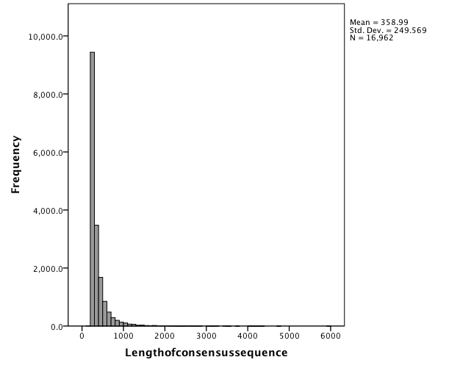

* Chart Builder.
GGRAPH
/GRAPHDATASET NAME="graphdataset" VARIABLES=Averagecoverage MISSING=LISTWISE REPORTMISSING=NO
/GRAPHSPEC SOURCE=INLINE.
BEGIN GPL
SOURCE: s=userSource(id("graphdataset"))
DATA: Averagecoverage=col(source(s), name("Averagecoverage"))
GUIDE: axis(dim(1), label("Averagecoverage"))
GUIDE: axis(dim(2), label("Frequency"))
ELEMENT: interval(position(summary.count(bin.rect(Averagecoverage))), shape.interior(shape.square))
END GPL.

GGraph

Notes
Output Created |  | 03-Oct-2011 14:11:03
Comments
Input | Data | /Users/srlab/Dropbox/Lab/Dave/OA Clam NGS/filtered_1000ppm_ACTTGA_L002_R1 trimmed mapping (16962 references).txt
Input | Active Dataset | DataSet3
Input | Filter | <none>
Input | Weight | <none>
Input | Split File | <none>
Input | N of Rows in Working Data File | 16962
Syntax |  | GGRAPH  /GRAPHDATASET NAME="graphdataset" VARIABLES=Averagecoverage MISSING=LISTWISE REPORTMISSING=NO  /GRAPHSPEC SOURCE=INLINE.  BEGIN GPL  SOURCE: s=userSource(id("graphdataset"))  DATA: Averagecoverage=col(source(s), name("Averagecoverage"))  GUIDE: axis(dim(1), label("Averagecoverage"))  GUIDE: axis(dim(2), label("Frequency"))  ELEMENT: interval(position(summary.count(bin.rect(Averagecoverage))), shape.interior(shape.square))  END GPL.
Resources | Processor Time | 00 00:00:00.846
Resources | Elapsed Time | 00 00:00:01.000

[DataSet3]

