GET DATA /TYPE=XLSX
/FILE='/Users/srlab/Dropbox/Lab/Dave/Manila OA/Manila OA1000ppm vs. 400ppm.xlsx'
/SHEET=name 'Manila OA1000ppm vs. 400ppm'
/CELLRANGE=full
/READNAMES=on
/ASSUMEDSTRWIDTH=32767.
EXECUTE.
DATASET NAME DataSet1 WINDOW=FRONT.
GRAPH
/SCATTERPLOT(BIVAR)=RPKM_A WITH RPKM
/MISSING=LISTWISE.

Graph

Notes
Output Created |  | 29-Feb-2012 11:55:46
Comments
Input | Active Dataset | DataSet1
Input | Filter | <none>
Input | Weight | <none>
Input | Split File | <none>
Input | N of Rows in Working Data File | 32606
Syntax |  | GRAPH  /SCATTERPLOT(BIVAR)=RPKM_A WITH RPKM  /MISSING=LISTWISE.
Resources | Processor Time | 00 00:00:05.667
Resources | Elapsed Time | 00 00:00:06.000

[DataSet1]

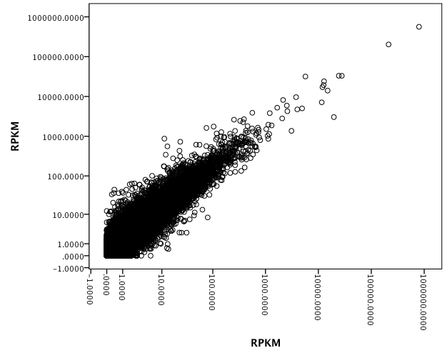

* Chart Builder.
GGRAPH
/GRAPHDATASET NAME="graphdataset" VARIABLES=RPKM_A RPKM Both MISSING=LISTWISE REPORTMISSING=NO
/GRAPHSPEC SOURCE=INLINE.
BEGIN GPL
SOURCE: s=userSource(id("graphdataset"))
DATA: RPKM_A=col(source(s), name("RPKM_A"))
DATA: RPKM=col(source(s), name("RPKM"))
DATA: Both=col(source(s), name("Both"), unit.category())
GUIDE: axis(dim(1), label("RPKM"))
GUIDE: axis(dim(2), label("RPKM"))
GUIDE: legend(aesthetic(aesthetic.color.exterior), label("Both"))
ELEMENT: point(position(RPKM_A*RPKM), color.exterior(Both))
END GPL.

GGraph

Notes
Output Created |  | 29-Feb-2012 12:00:53
Comments
Input | Active Dataset | DataSet1
Input | Filter | <none>
Input | Weight | <none>
Input | Split File | <none>
Input | N of Rows in Working Data File | 32606
Syntax |  | GGRAPH  /GRAPHDATASET NAME="graphdataset" VARIABLES=RPKM_A RPKM Both MISSING=LISTWISE REPORTMISSING=NO  /GRAPHSPEC SOURCE=INLINE.  BEGIN GPL  SOURCE: s=userSource(id("graphdataset"))  DATA: RPKM_A=col(source(s), name("RPKM_A"))  DATA: RPKM=col(source(s), name("RPKM"))  DATA: Both=col(source(s), name("Both"), unit.category())  GUIDE: axis(dim(1), label("RPKM"))  GUIDE: axis(dim(2), label("RPKM"))  GUIDE: legend(aesthetic(aesthetic.color.exterior), label("Both"))  ELEMENT: point(position(RPKM_A*RPKM), color.exterior(Both))  END GPL.
Resources | Processor Time | 00 00:00:02.313
Resources | Elapsed Time | 00 00:00:03.000

[DataSet1]

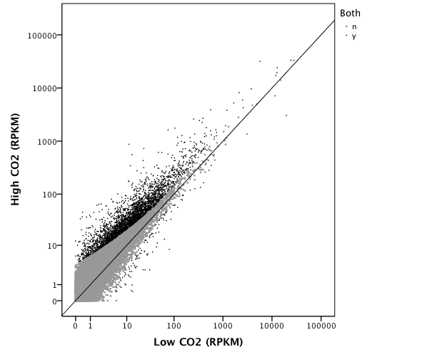

GGraph

Notes
Output Created |  | 29-Feb-2012 13:35:31
Comments
Input | Active Dataset | DataSet1
Input | Filter | <none>
Input | Weight | <none>
Input | Split File | <none>
Input | N of Rows in Working Data File | 23944
Syntax |  | GGRAPH  /GRAPHDATASET NAME="graphdataset" VARIABLES=Averagecoverage MISSING=LISTWISE REPORTMISSING=NO  /GRAPHSPEC SOURCE=INLINE.  BEGIN GPL  SOURCE: s=userSource(id("graphdataset"))  DATA: Averagecoverage=col(source(s), name("Averagecoverage"))  GUIDE: axis(dim(1), label("Average coverage"))  GUIDE: axis(dim(2), label("Frequency"))  ELEMENT: interval(position(summary.count(bin.rect(Averagecoverage))), shape.interior(shape.square))  END GPL.
Resources | Processor Time | 00 00:00:01.511
Resources | Elapsed Time | 00 00:00:02.000

[DataSet1]

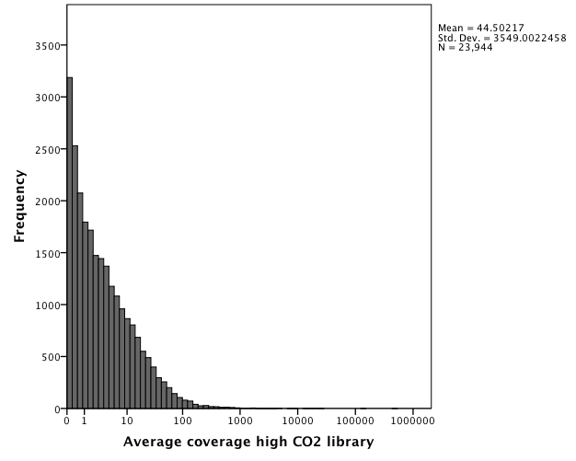

GET DATA /TYPE=XLSX
/FILE='/Users/srlab/Dropbox/Lab/Dave/Manila OA/filtered_1000ppm_ACTTGA_L002_R1 trimmed mapping (23944 references).xlsx'
/SHEET=name 'filtered_1000ppm_ACTTGA_L002_R1'
/CELLRANGE=full
/READNAMES=on
/ASSUMEDSTRWIDTH=32767.
EXECUTE.
DATASET NAME DataSet1 WINDOW=FRONT.
* Chart Builder.
GGRAPH
/GRAPHDATASET NAME="graphdataset" VARIABLES=Averagecoverage MISSING=LISTWISE REPORTMISSING=NO
/GRAPHSPEC SOURCE=INLINE.
BEGIN GPL
SOURCE: s=userSource(id("graphdataset"))
DATA: Averagecoverage=col(source(s), name("Averagecoverage"))
GUIDE: axis(dim(1), label("Average coverage"))
GUIDE: axis(dim(2), label("Frequency"))
ELEMENT: interval(position(summary.count(bin.rect(Averagecoverage))), shape.interior(shape.square))
END GPL.

GET DATA /TYPE=XLSX
/FILE='/Users/srlab/Dropbox/Lab/Dave/Manila OA/Manila OA1000ppm vs. 400ppm subexperiment.xlsx'
/SHEET=name '1000ppm vs. 400ppm subexperimen'
/CELLRANGE=full
/READNAMES=on
/ASSUMEDSTRWIDTH=32767.
EXECUTE.
DATASET NAME DataSet2 WINDOW=FRONT.
* Chart Builder.
GGRAPH
/GRAPHDATASET NAME="graphdataset" VARIABLES=RPKM_A RPKM V10 MISSING=LISTWISE REPORTMISSING=NO
/GRAPHSPEC SOURCE=INLINE.
BEGIN GPL
SOURCE: s=userSource(id("graphdataset"))
DATA: RPKM_A=col(source(s), name("RPKM_A"))
DATA: RPKM=col(source(s), name("RPKM"))
DATA: V10=col(source(s), name("V10"), unit.category())
GUIDE: axis(dim(1), label("RPKM"))
GUIDE: axis(dim(2), label("RPKM"))
GUIDE: legend(aesthetic(aesthetic.color.exterior), label("V10"))
ELEMENT: point(position(RPKM_A*RPKM), color.exterior(V10))
END GPL.

GGraph

Notes
Output Created |  | 29-Feb-2012 12:19:21
Comments
Input | Active Dataset | DataSet2
Input | Filter | <none>
Input | Weight | <none>
Input | Split File | <none>
Input | N of Rows in Working Data File | 17048
Syntax |  | GGRAPH  /GRAPHDATASET NAME="graphdataset" VARIABLES=RPKM_A RPKM V10 MISSING=LISTWISE REPORTMISSING=NO  /GRAPHSPEC SOURCE=INLINE.  BEGIN GPL  SOURCE: s=userSource(id("graphdataset"))  DATA: RPKM_A=col(source(s), name("RPKM_A"))  DATA: RPKM=col(source(s), name("RPKM"))  DATA: V10=col(source(s), name("V10"), unit.category())  GUIDE: axis(dim(1), label("RPKM"))  GUIDE: axis(dim(2), label("RPKM"))  GUIDE: legend(aesthetic(aesthetic.color.exterior), label("V10"))  ELEMENT: point(position(RPKM_A*RPKM), color.exterior(V10))  END GPL.
Resources | Processor Time | 00 00:00:01.340
Resources | Elapsed Time | 00 00:00:02.000

[DataSet2]

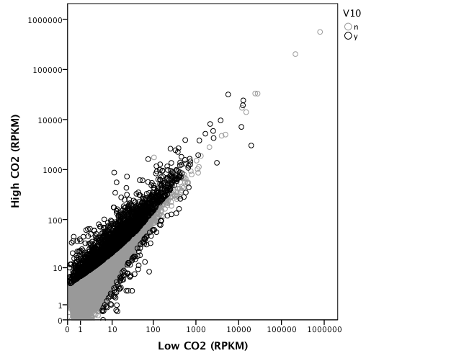

GET DATA /TYPE=XLSX
/FILE='/Users/srlab/Dropbox/Lab/Dave/Manila OA/Manila OA1000ppm vs. 400ppm.xlsx'
/SHEET=name 'Manila OA1000ppm vs. 400ppm'
/CELLRANGE=full
/READNAMES=on
/ASSUMEDSTRWIDTH=32767.
EXECUTE.
DATASET NAME DataSet2 WINDOW=FRONT.
SORT CASES BY RPKM(A).
DATASET ACTIVATE DataSet1.
* Chart Builder.
GGRAPH
/GRAPHDATASET NAME="graphdataset" VARIABLES=Lengthofconsensussequence MISSING=LISTWISE REPORTMISSING=NO
/GRAPHSPEC SOURCE=INLINE.
BEGIN GPL
SOURCE: s=userSource(id("graphdataset"))
DATA: Lengthofconsensussequence=col(source(s), name("Lengthofconsensussequence"))
GUIDE: axis(dim(1), label("Length of consensus sequence"))
GUIDE: axis(dim(2), label("Frequency"))
ELEMENT: interval(position(summary.count(bin.rect(Lengthofconsensussequence))), shape.interior(shape.square))
END GPL.

GGraph

Notes
Output Created |  | 29-Feb-2012 13:54:26
Comments
Input | Active Dataset | DataSet1
Input | Filter | <none>
Input | Weight | <none>
Input | Split File | <none>
Input | N of Rows in Working Data File | 23944
Syntax |  | GGRAPH  /GRAPHDATASET NAME="graphdataset" VARIABLES=Lengthofconsensussequence MISSING=LISTWISE REPORTMISSING=NO  /GRAPHSPEC SOURCE=INLINE.  BEGIN GPL  SOURCE: s=userSource(id("graphdataset"))  DATA: Lengthofconsensussequence=col(source(s), name("Lengthofconsensussequence"))  GUIDE: axis(dim(1), label("Length of consensus sequence"))  GUIDE: axis(dim(2), label("Frequency"))  ELEMENT: interval(position(summary.count(bin.rect(Lengthofconsensussequence))), shape.interior(shape.square))  END GPL.
Resources | Processor Time | 00 00:00:00.904
Resources | Elapsed Time | 00 00:00:01.000

[DataSet1]

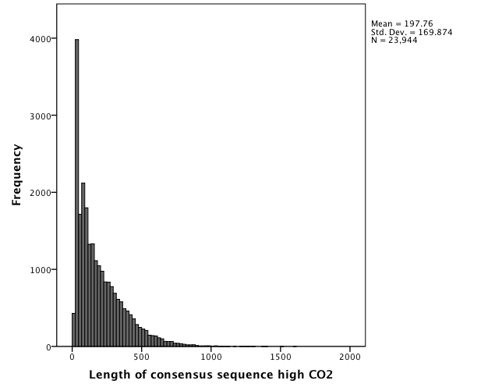

* Chart Builder.
GGRAPH
/GRAPHDATASET NAME="graphdataset" VARIABLES=Numberofreads MISSING=LISTWISE REPORTMISSING=NO
/GRAPHSPEC SOURCE=INLINE.
BEGIN GPL
SOURCE: s=userSource(id("graphdataset"))
DATA: Numberofreads=col(source(s), name("Numberofreads"))
GUIDE: axis(dim(1), label("Number of reads"))
GUIDE: axis(dim(2), label("Frequency"))
ELEMENT: interval(position(summary.count(bin.rect(Numberofreads))), shape.interior(shape.square))
END GPL.

GGraph

Notes
Output Created |  | 29-Feb-2012 13:55:00
Comments
Input | Active Dataset | DataSet1
Input | Filter | <none>
Input | Weight | <none>
Input | Split File | <none>
Input | N of Rows in Working Data File | 23944
Syntax |  | GGRAPH  /GRAPHDATASET NAME="graphdataset" VARIABLES=Numberofreads MISSING=LISTWISE REPORTMISSING=NO  /GRAPHSPEC SOURCE=INLINE.  BEGIN GPL  SOURCE: s=userSource(id("graphdataset"))  DATA: Numberofreads=col(source(s), name("Numberofreads"))  GUIDE: axis(dim(1), label("Number of reads"))  GUIDE: axis(dim(2), label("Frequency"))  ELEMENT: interval(position(summary.count(bin.rect(Numberofreads))), shape.interior(shape.square))  END GPL.
Resources | Processor Time | 00 00:00:00.883
Resources | Elapsed Time | 00 00:00:01.000

[DataSet1]

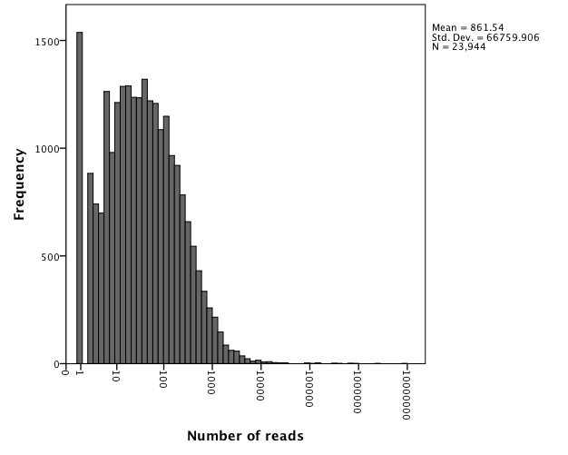

* Chart Builder.
GGRAPH
/GRAPHDATASET NAME="graphdataset" VARIABLES=Averagecoverage MISSING=LISTWISE REPORTMISSING=NO
/GRAPHSPEC SOURCE=INLINE.
BEGIN GPL
SOURCE: s=userSource(id("graphdataset"))
DATA: Averagecoverage=col(source(s), name("Averagecoverage"))
GUIDE: axis(dim(1), label("Average coverage"))
GUIDE: axis(dim(2), label("Frequency"))
ELEMENT: interval(position(summary.count(bin.rect(Averagecoverage))), shape.interior(shape.square))
END GPL.

GGraph

Notes
Output Created |  | 29-Feb-2012 16:56:47
Comments
Input | Active Dataset | DataSet1
Input | Filter | <none>
Input | Weight | <none>
Input | Split File | <none>
Input | N of Rows in Working Data File | 26006
Syntax |  | GGRAPH  /GRAPHDATASET NAME="graphdataset" VARIABLES=Averagecoverage MISSING=LISTWISE REPORTMISSING=NO  /GRAPHSPEC SOURCE=INLINE.  BEGIN GPL  SOURCE: s=userSource(id("graphdataset"))  DATA: Averagecoverage=col(source(s), name("Averagecoverage"))  GUIDE: axis(dim(1), label("Average coverage"))  GUIDE: axis(dim(2), label("Frequency"))  ELEMENT: interval(position(summary.count(bin.rect(Averagecoverage))), shape.interior(shape.square))  END GPL.
Resources | Processor Time | 00 00:00:01.557
Resources | Elapsed Time | 00 00:00:01.000

[DataSet1]

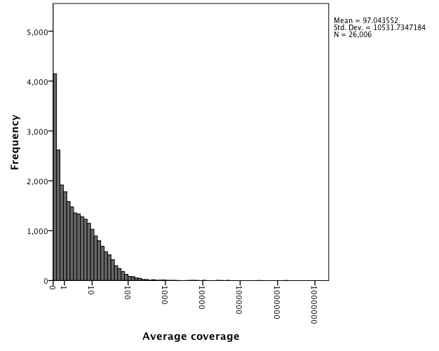

* Chart Builder.
GGRAPH
/GRAPHDATASET NAME="graphdataset" VARIABLES=Numberofreads MISSING=LISTWISE REPORTMISSING=NO
/GRAPHSPEC SOURCE=INLINE.
BEGIN GPL
SOURCE: s=userSource(id("graphdataset"))
DATA: Numberofreads=col(source(s), name("Numberofreads"))
GUIDE: axis(dim(1), label("Number of reads"))
GUIDE: axis(dim(2), label("Frequency"))
ELEMENT: interval(position(summary.count(bin.rect(Numberofreads))), shape.interior(shape.square))
END GPL.

GGraph

Notes
Output Created |  | 29-Feb-2012 16:58:48
Comments
Input | Active Dataset | DataSet1
Input | Filter | <none>
Input | Weight | <none>
Input | Split File | <none>
Input | N of Rows in Working Data File | 26006
Syntax |  | GGRAPH  /GRAPHDATASET NAME="graphdataset" VARIABLES=Numberofreads MISSING=LISTWISE REPORTMISSING=NO  /GRAPHSPEC SOURCE=INLINE.  BEGIN GPL  SOURCE: s=userSource(id("graphdataset"))  DATA: Numberofreads=col(source(s), name("Numberofreads"))  GUIDE: axis(dim(1), label("Number of reads"))  GUIDE: axis(dim(2), label("Frequency"))  ELEMENT: interval(position(summary.count(bin.rect(Numberofreads))), shape.interior(shape.square))  END GPL.
Resources | Processor Time | 00 00:00:00.896
Resources | Elapsed Time | 00 00:00:01.000

[DataSet1]

