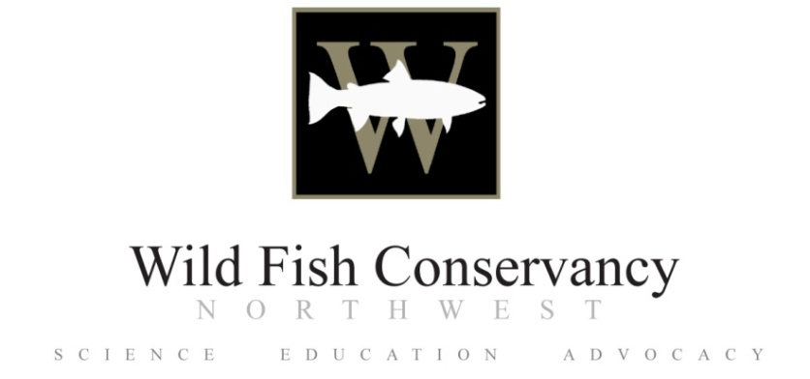

**Interns Needed for a Juvenile Salmon/Fish Community**

**Ecology Study in Gray Harbor**

The Wild Fish Conservancy is seeking interns to assist in an assessment of habitat use by the fish community (particularly juvenile salmon) in the tidally-influenced areas of the Chehalis River estuary (Grays Harbor) and tributaries. The sampling effort will use fyke trapping and beach seining to capture, identify, measure, and release juvenile fish from March to September, 2012. Habitat assessments will also be made to identify areas for future habitat restoration projects to aid in salmon recovery in the Chehalis Basin. Volunteers need to be in good physical condition (adequate for hauling seine nets and traveling across mud flats), be comfortable working from small boats, and be willing to work in adverse weather conditions. The effort will provide experience in field techniques, fish identification, data collection and habitat assessment. Free group lodging will be provided in Westport, but at present there is no funding for salaries or stipends. Interns do not need to commit to the entire study period, but during summer, preference will be given to those who can commit for longer time periods (weeks/months).

If interested, please return the completed form to **James Fletcher** ([james@wildfishconservancy.org](mailto:james@wildfishconservancy.org))

Secondary contact: **Todd Sandell** ([todd@wildfishconservancy.org](mailto:todd@wildfishconservancy.org))

For information on the WFC: [www.wildfishconservancy.org](http://www.wildfishconservancy.org)

**2012 Grays Harbor intern/volunteer application form**

**Name:**  Derek Brady

**Email:**  [derekbrady22@gmail.com](mailto:derekbrady22@gmail.com)

**Contact number:** (253) – 691 – 1127

**Address:** 5011 18th AVE NE, Seattle, Wa. 98105

**Availability (please be as specific as possible):**

For Spring Quarter: (March 25th – June 5th) I am available almost full time; during the spring I will be taking one class for my senior capstone (project) however, the last section consists of a scientific paper and end term presentation which can be accomplished mostly off campus. There may be times when I am required to return to the University/USAFR for advisory appointments and drill weekends. These meetings/drill weekends would occur only once a month.

During the Spring I would like to set up a repeating schedule; for example 3 weeks on working in Grays Harbor and then 1 week off in Seattle to complete my senior project, attend meetings and complete my USAF reserve commitment (2days once a month).

However my schedule is highly flexible and open to change.

For Summer Quarter: Not yet determined.

**Affiliation (if you are currently a student please state your Major/Minor):**

University of Washington, Major – Aquatic Fisheries and Sciences, Minor – Marine Biology

**Do you intend to use this field work for academic credit?** Yes

**Height and foot size (for fitting waders):** HT: 6 feet, Foot Size 11mens

**Medical concern or allergy? (information will be strictly confidential)** none

**Can you swim?** Yes

**Emergency contact and phone number** Lee and Kim Brady: (253) 846 – 0775 , Lee Brady Cell: 253 - 691 - 4731, Kim Cell: 253 – 691 – 8871

*Briefly describe your interest in WFC’s research studying habitat use by the fish in the Chehalis River estuary. Please include any previous field work, boating experience, and specify your ability to perform the work. If you are currently a student, what are your academic goals and how will working on this project help you achieve them?*

I became interested in fishery science several years earlier and am expecting graduation from the University of Washington’s School of Aquatic Fisheries and Sciences this June. The WFC’s conservation research will provide me with field experience that I cannot obtain from the laboratory or classroom. Initially my interest lied with animal molecular/genetic physiology because of the great detail of information you can learn from genes, proteins and physiological systems. Last year my interests shifted to fishery ecology and conservation management because I began to see how desperate the wild populations of salmon were along our coasts and I enjoy being outdoors working within the environment.

I would greatly appreciate the opportunity to work with the WFC in furthering our understanding of how juvenile fish utilize habitat within estuaries. My experiences include:

* 1 year laboratory and environmental field work experience

-Proficient in laboratory DNA primer design, Polymerase Chain Reaction, Quantitative PCR, cDNA conversion, gene/protein analysis; Working knowledge in stomach content analysis

- Proficient in field trawling, marine/freshwater species dissection, Sound/lake/river surveying; Working knowledge in electro fishing, PNW species identification

* 8 years Small boat operation experience and have Washington State boating license
* 1 month at sea experience on UW’s research vessel Thomas G. Thompson working with School of Oceanography on the Ocean Observatory Initiative, where I assisted in day to day operations related to ocean floor surveying
* 7 years team management, logistical and leadership experience as a loadmaster with the USAF. Examples of experience include Presidential Support Missions, 2006 – 2008,support included transport of President’s helicopter, limos, ambulance and Secret Service personnel; National Science Foundation Antarctic Resupply Mission, McMurdo Station, November 2008

My current academic goals include completing my senior project, gaining field experience in ecology, conservation or aquaculture, applying for work within the fisheries career field and graduating in June 2012. Completing an internship with WFC will show a positive example to potential employers that I am knowledgeable in field conservation techniques and am willing to seek out experience. Also, this experience will allow me to diversify what I have accomplished in the field and will aid in the decision as to which direction my career in fisheries will go over the next several years.

Thank you for your interest in my application and I look forward to hearing from you.

Derek Brady