

Be it known that: DAVID C. METZGER

Has satisfied the requirements for a training course in

Biosafety Training

Issued: January 11, 2011 Expiration Date: January 10, 2014

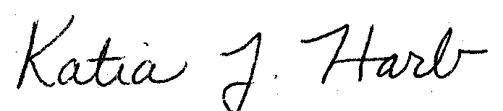
______________________________
Mgr. Research and Biological Safety

This certificate is issued by Environmental Health & Safety

