## Gel Image

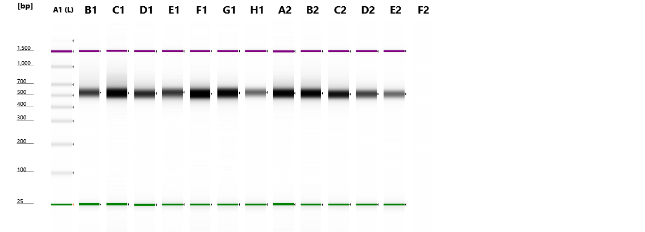

**HS D1000**Contrast: 0.50

## Sample Info

|  |  |  |  |  |
| --- | --- | --- | --- | --- |
| **Well** | **Conc. [pg/µl]** | **Sample Description** | **Alert** | **Observations** |
| A1 | 1670 | Ladder |  | Ladder |
| B1 | 5640 | JD002_A |  |  |
| C1 | 13600 | JD002_B |  |  |
| D1 | 7170 | JD002_C |  |  |
| E1 | 6470 | JD002_D |  |  |
| F1 | 16200 | JD002_E |  |  |
| G1 | 13000 | JD002_F |  |  |
| H1 | 3750 | JD002_G |  |  |
| A2 | 11700 | JD002_H |  |  |
| B2 | 11600 | JD002_I |  |  |
| C2 | 8610 | JD002_J |  |  |
| D2 | 5360 | JD002_K |  |  |
| E2 | 3510 | JD002_L |  |  |
| F2 |  |  | ! | Marker(s) not detected |

|  |  |  |  |
| --- | --- | --- | --- |
| A1  image0.png  Ladder | B1  image0.png  JD002_A | C1  image0.png  JD002_B | D1  image0.png  JD002_C |
| E1  image0.png  JD002_D | F1  image0.png  JD002_E | G1  image0.png  JD002_F | H1  image0.png  JD002_G |
| A2  image0.png  JD002_H | B2  image0.png  JD002_I | C2  image0.png  JD002_J | D2  image0.png  JD002_K |
| E2  image0.png  JD002_L | F2  image0.png |  |  |

**A1**

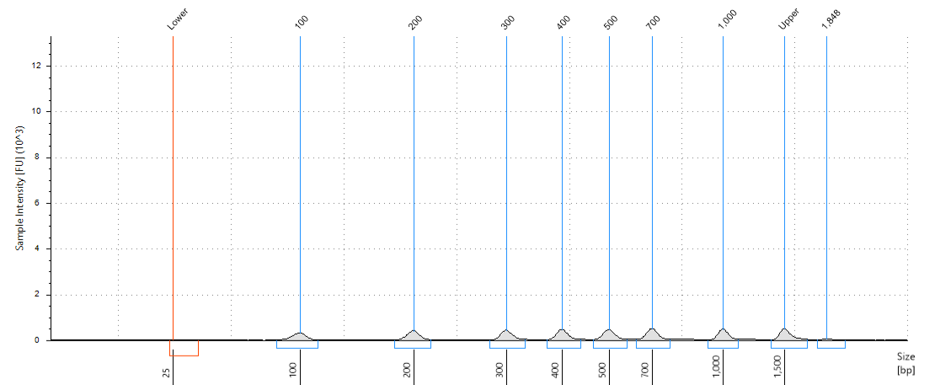

Ladder

## Peak Table

|  |  |  |  |  |  |  |
| --- | --- | --- | --- | --- | --- | --- |
| **Size [bp]** | **Calibrated Conc. [pg/µl]** | **Assigned Conc. [pg/µl]** | **Peak Molarity [pmol/l]** | **% Integrated Area** | **Peak Comment** | **Observations** |
| 25 | 18.3 | - | 1130 | - |  | Lower Marker |
| 100 | 198 | - | 3050 | 11.87 |  |  |
| 200 | 224 | - | 1720 | 13.40 |  |  |
| 300 | 228 | - | 1170 | 13.67 |  |  |
| 400 | 243 | - | 935 | 14.55 |  |  |
| 500 | 251 | - | 772 | 15.03 |  |  |
| 700 | 265 | - | 581 | 15.84 |  |  |
| 1,000 | 230 | - | 354 | 13.78 |  |  |
| 1,500 | 250 | 250 | 256 | - |  | Upper Marker |
| 1,848 | 30.8 | - | 25.7 | 1.85 |  |  |

**B1**

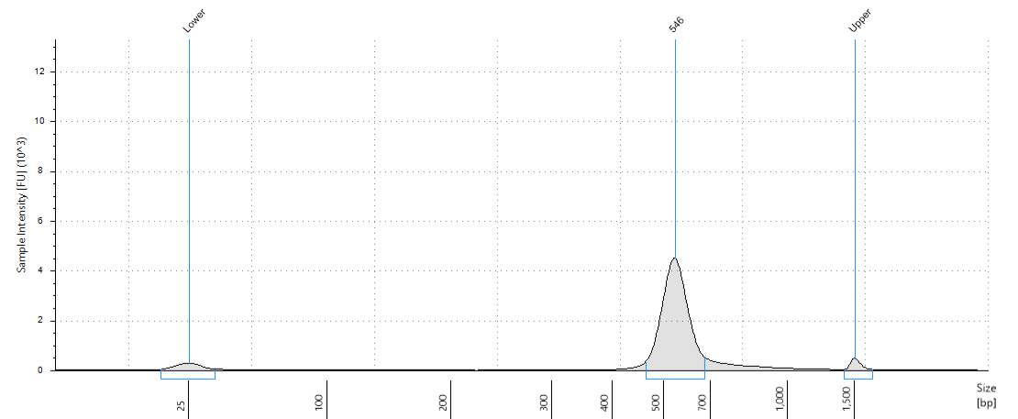

JD002_A

## Peak Table

|  |  |  |  |  |  |  |
| --- | --- | --- | --- | --- | --- | --- |
| **Size [bp]** | **Calibrated Conc. [pg/µl]** | **Assigned Conc. [pg/µl]** | **Peak Molarity [pmol/l]** | **% Integrated Area** | **Peak Comment** | **Observations** |
| 25 | 370 | - | 22800 | - |  | Lower Marker |
| 546 | 5640 | - | 15900 | 100.00 |  |  |
| 1,500 | 250 | 250 | 256 | - |  | Upper Marker |

**C1**

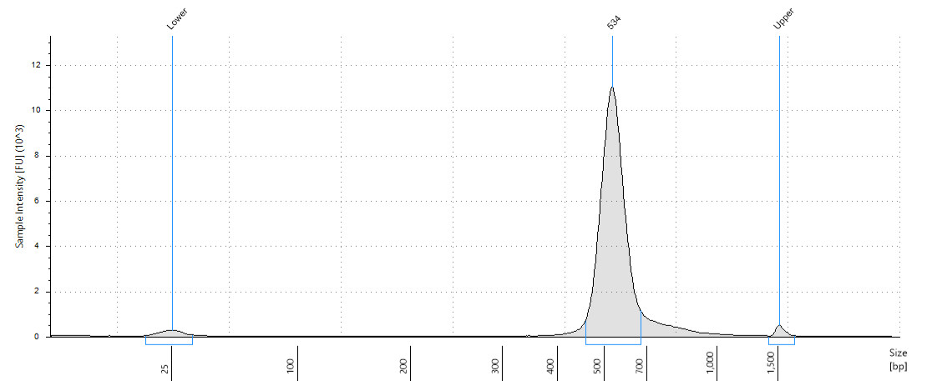

JD002_B

## Peak Table

|  |  |  |  |  |  |  |
| --- | --- | --- | --- | --- | --- | --- |
| **Size [bp]** | **Calibrated Conc. [pg/µl]** | **Assigned Conc. [pg/µl]** | **Peak Molarity [pmol/l]** | **% Integrated Area** | **Peak Comment** | **Observations** |
| 25 | 379 | - | 23300 | - |  | Lower Marker |
| 534 | 13600 | - | 39100 | 100.00 |  |  |
| 1,500 | 250 | 250 | 256 | - |  | Upper Marker |

**D1**

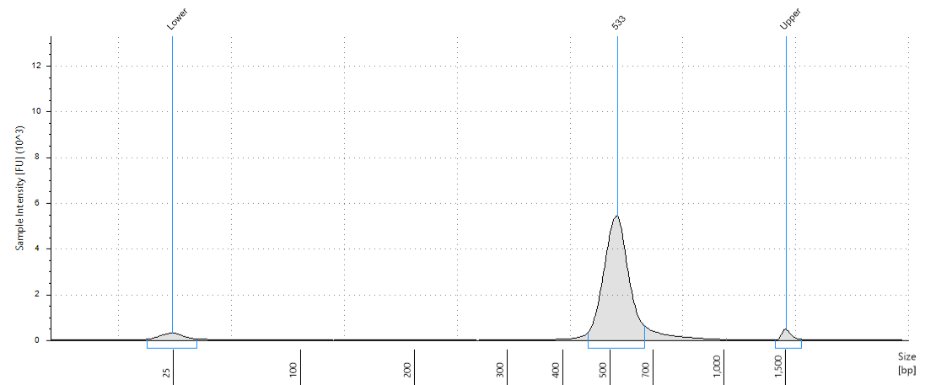

JD002_C

## Peak Table

|  |  |  |  |  |  |  |
| --- | --- | --- | --- | --- | --- | --- |
| **Size [bp]** | **Calibrated Conc. [pg/µl]** | **Assigned Conc. [pg/µl]** | **Peak Molarity [pmol/l]** | **% Integrated Area** | **Peak Comment** | **Observations** |
| 25 | 414 | - | 25500 | - |  | Lower Marker |
| 533 | 7170 | - | 20700 | 100.00 |  |  |
| 1,500 | 250 | 250 | 256 | - |  | Upper Marker |

**E1**

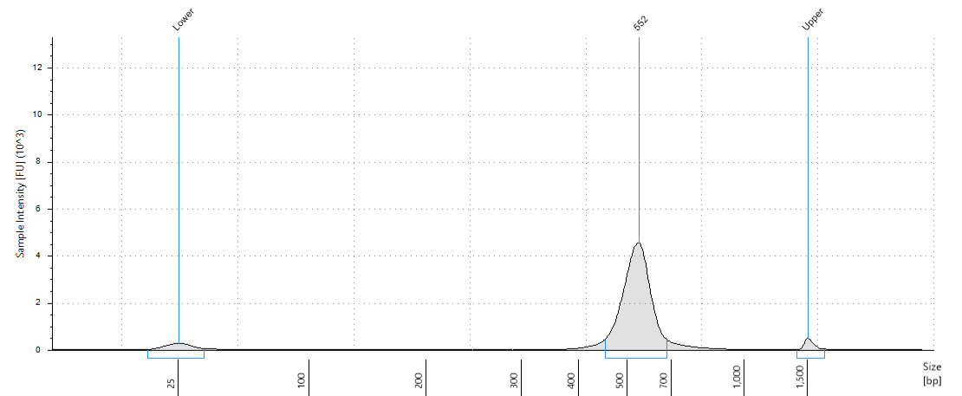

JD002_D

## Peak Table

|  |  |  |  |  |  |  |
| --- | --- | --- | --- | --- | --- | --- |
| **Size [bp]** | **Calibrated Conc. [pg/µl]** | **Assigned Conc. [pg/µl]** | **Peak Molarity [pmol/l]** | **% Integrated Area** | **Peak Comment** | **Observations** |
| 25 | 404 | - | 24900 | - |  | Lower Marker |
| 552 | 6470 | - | 18000 | 100.00 |  |  |
| 1,500 | 250 | 250 | 256 | - |  | Upper Marker |

**F1**

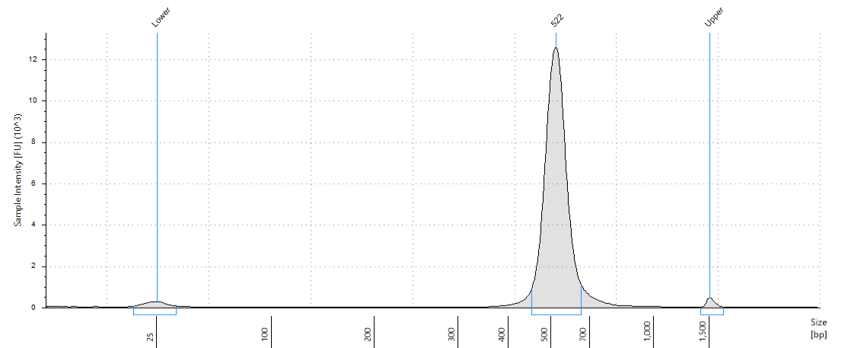

JD002_E

## Peak Table

|  |  |  |  |  |  |  |
| --- | --- | --- | --- | --- | --- | --- |
| **Size [bp]** | **Calibrated Conc. [pg/µl]** | **Assigned Conc. [pg/µl]** | **Peak Molarity [pmol/l]** | **% Integrated Area** | **Peak Comment** | **Observations** |
| 25 | 409 | - | 25200 | - |  | Lower Marker |
| 522 | 16200 | - | 47700 | 100.00 |  |  |
| 1,500 | 250 | 250 | 256 | - |  | Upper Marker |

**G1**

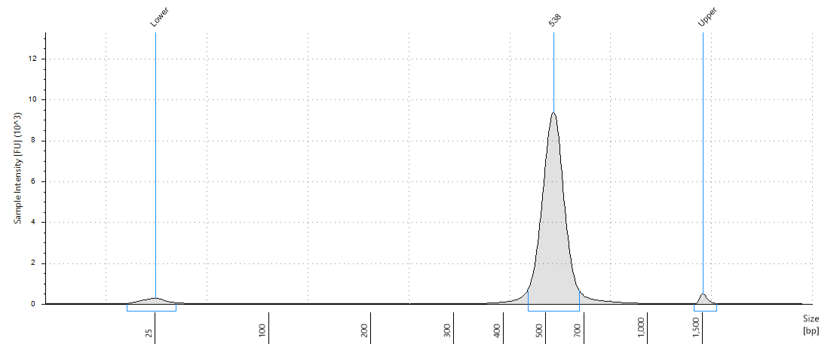

JD002_F

## Peak Table

|  |  |  |  |  |  |  |
| --- | --- | --- | --- | --- | --- | --- |
| **Size [bp]** | **Calibrated Conc. [pg/µl]** | **Assigned Conc. [pg/µl]** | **Peak Molarity [pmol/l]** | **% Integrated Area** | **Peak Comment** | **Observations** |
| 25 | 431 | - | 26500 | - |  | Lower Marker |
| 538 | 13000 | - | 37000 | 100.00 |  |  |
| 1,500 | 250 | 250 | 256 | - |  | Upper Marker |

**H1**

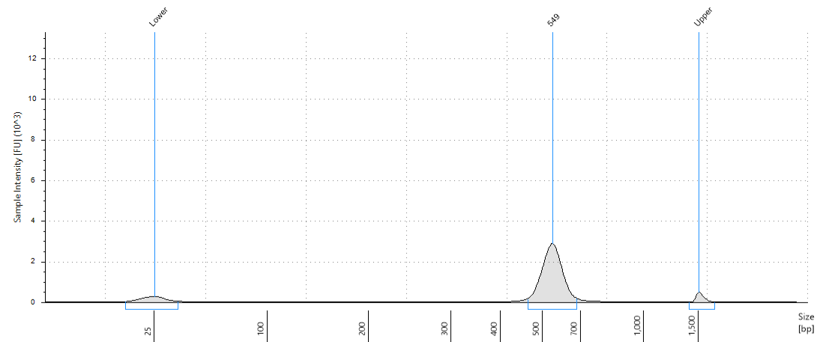

JD002_G

## Peak Table

|  |  |  |  |  |  |  |
| --- | --- | --- | --- | --- | --- | --- |
| **Size [bp]** | **Calibrated Conc. [pg/µl]** | **Assigned Conc. [pg/µl]** | **Peak Molarity [pmol/l]** | **% Integrated Area** | **Peak Comment** | **Observations** |
| 25 | 458 | - | 28200 | - |  | Lower Marker |
| 549 | 3750 | - | 10500 | 100.00 |  |  |
| 1,500 | 250 | 250 | 256 | - |  | Upper Marker |

**A2**

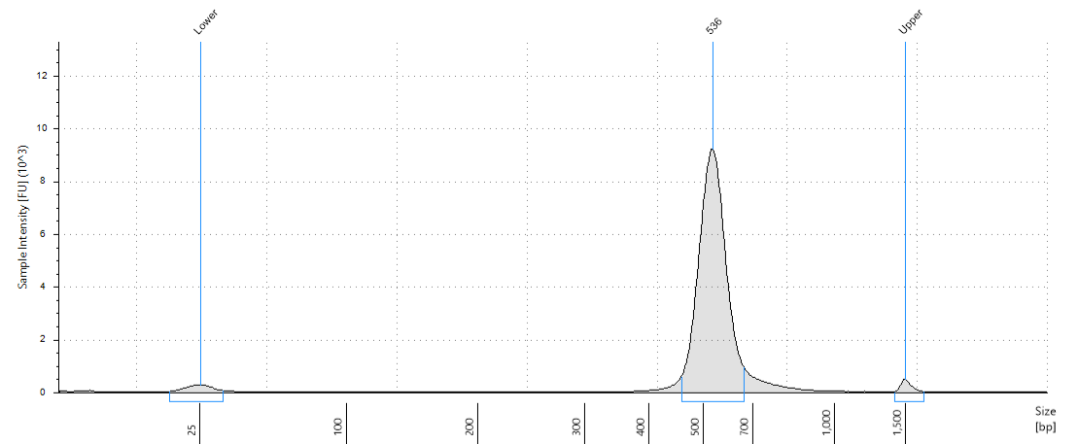

JD002_H

## Peak Table

|  |  |  |  |  |  |  |
| --- | --- | --- | --- | --- | --- | --- |
| **Size [bp]** | **Calibrated Conc. [pg/µl]** | **Assigned Conc. [pg/µl]** | **Peak Molarity [pmol/l]** | **% Integrated Area** | **Peak Comment** | **Observations** |
| 25 | 372 | - | 22900 | - |  | Lower Marker |
| 536 | 11700 | - | 33500 | 100.00 |  |  |
| 1,500 | 250 | 250 | 256 | - |  | Upper Marker |

**B2**

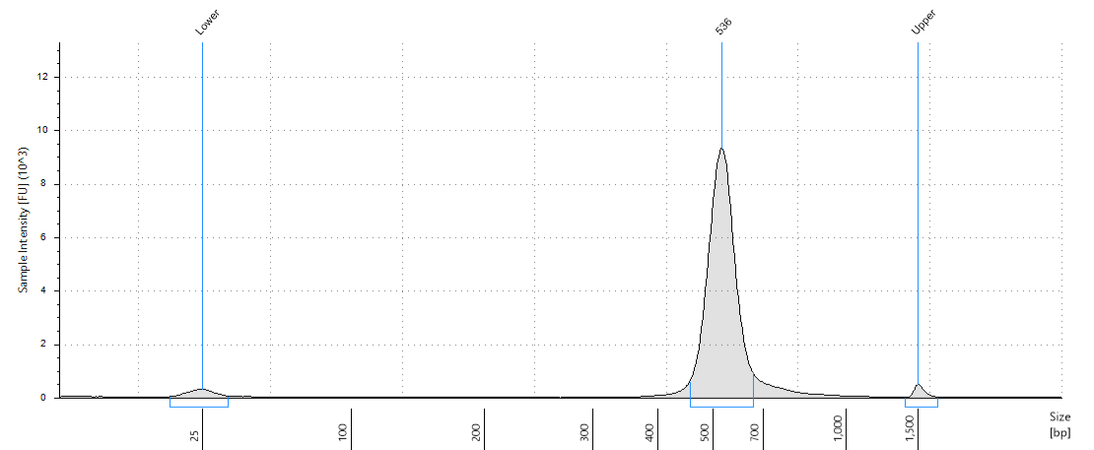

JD002_I

## Peak Table

|  |  |  |  |  |  |  |
| --- | --- | --- | --- | --- | --- | --- |
| **Size [bp]** | **Calibrated Conc. [pg/µl]** | **Assigned Conc. [pg/µl]** | **Peak Molarity [pmol/l]** | **% Integrated Area** | **Peak Comment** | **Observations** |
| 25 | 418 | - | 25700 | - |  | Lower Marker |
| 536 | 11600 | - | 33400 | 100.00 |  |  |
| 1,500 | 250 | 250 | 256 | - |  | Upper Marker |

**C2**

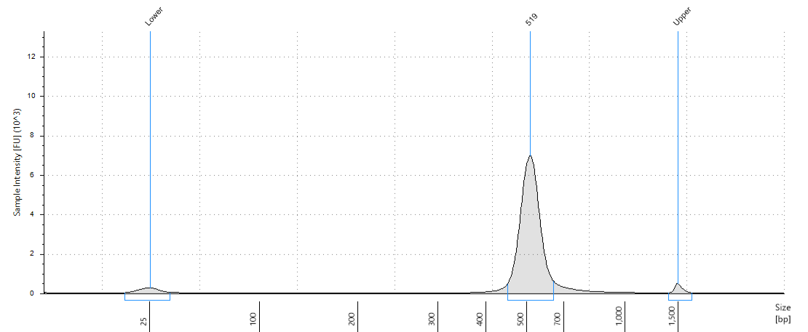

JD002_J

## Peak Table

|  |  |  |  |  |  |  |
| --- | --- | --- | --- | --- | --- | --- |
| **Size [bp]** | **Calibrated Conc. [pg/µl]** | **Assigned Conc. [pg/µl]** | **Peak Molarity [pmol/l]** | **% Integrated Area** | **Peak Comment** | **Observations** |
| 25 | 381 | - | 23500 | - |  | Lower Marker |
| 519 | 8610 | - | 25500 | 100.00 |  |  |
| 1,500 | 250 | 250 | 256 | - |  | Upper Marker |

**D2**

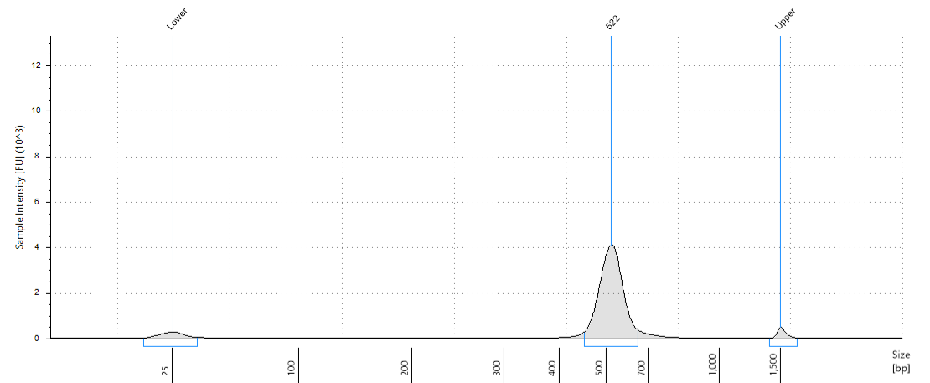

JD002_K

## Peak Table

|  |  |  |  |  |  |  |
| --- | --- | --- | --- | --- | --- | --- |
| **Size [bp]** | **Calibrated Conc. [pg/µl]** | **Assigned Conc. [pg/µl]** | **Peak Molarity [pmol/l]** | **% Integrated Area** | **Peak Comment** | **Observations** |
| 25 | 400 | - | 24600 | - |  | Lower Marker |
| 522 | 5360 | - | 15800 | 100.00 |  |  |
| 1,500 | 250 | 250 | 256 | - |  | Upper Marker |

**E2**

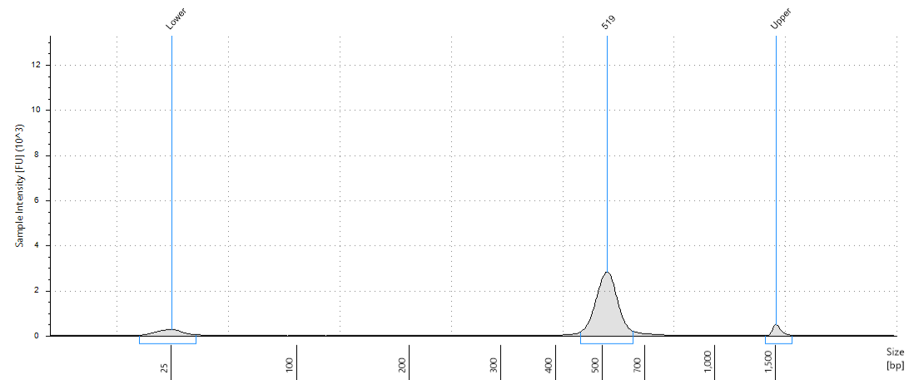

JD002_L

## Peak Table

|  |  |  |  |  |  |  |
| --- | --- | --- | --- | --- | --- | --- |
| **Size [bp]** | **Calibrated Conc. [pg/µl]** | **Assigned Conc. [pg/µl]** | **Peak Molarity [pmol/l]** | **% Integrated Area** | **Peak Comment** | **Observations** |
| 25 | 433 | - | 26700 | - |  | Lower Marker |
| 519 | 3510 | - | 10400 | 100.00 |  |  |
| 1,500 | 250 | 250 | 256 | - |  | Upper Marker |

**F2**

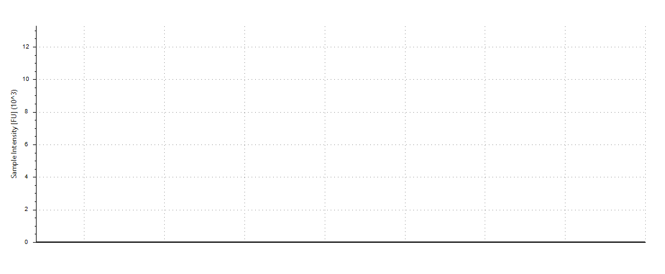

## Peak Table

|  |  |  |  |  |  |  |
| --- | --- | --- | --- | --- | --- | --- |
| **Size [bp]** | **Calibrated Conc. [pg/µl]** | **Assigned Conc. [pg/µl]** | **Peak Molarity [pmol/l]** | **% Integrated Area** | **Peak Comment** | **Observations** |