Research Plan

University of Washington Principal Investigator: Dr. Steven Roberts
University of Washington Technical Lead: Mackenzie Gavery
Nanostring Principal Investigator: Dr. Philippa Webster
NanoString Technical Lead: Dr. Jeannette Nussbaum

Background and Rationale

DNA methylation is an epigenetic modification of DNA that is associated with the control of gene transcription. It is characterized by the addition of a methyl group to position 5 of the cytosine ring in a CpG dinucleotide, a reaction which is catalyzed by DNA methyltransferase enzymes. DNA methylation patterns are well established during embryonic development with every cell type displaying a unique methylation “fingerprint”. During cell division, the methylation pattern passes over to the daughter cell where the original pattern is maintained after DNA replication. Changes in gene methylation can result in developmental disorders and tumorigenesis. DNA methylation has therefore emerged as a promising molecular biomarker for disease and created a significant need for technologies able to detect and quantitate DNA methylation.
NanoString has developed a novel technology for direct, multiplexed measurement of nucleic acids. The nCounter Analysis System utilizes a novel digital technology that offers high levels of precision and sensitivity (<1 copy per cell). The technology uses molecular "barcodes" and single molecule imaging to detect and count hundreds of unique targets in a single reaction. Each color-coded barcode is attached to a single target-specific probe corresponding to a sequence of interest. Mixed together with controls, they form a multiplexed CodeSet.
NanoString is developing a multiplexed assay for quantitating methylation at up to 800 sites in a single reaction. This assay is based on a methylation-sensitive restriction enzyme (MSRE) digestion protocol, in which the level of digestion is measured using the nCounter Analysis System. Testing this novel assay on previously characterized samples will be an important means of validating its performance.

The Roberts lab in the School of Aquatic and Fishery Sciences (SAFS) at the University of Washington is interested in studying DNA methylation patterns as a potential biomarker for assessing the impact of environmental stressors on marine organisms in general and on the Pacific Oyster (Crassostrea gigas) in specific. Their group has been using methylation sensitive PCR and bisulfate sequencing PCR approaches to identify CpG methylation. The availability of a simple and accurate multiplexed assay to quantify DNA methylation at hundreds of CpG sites simultaneously would greatly facilitate and expedite this research.

Project Overview

1. The Roberts Lab will provide a list to NanoString with C. gigas sequences containing CCGG cut sites predicted to be methylated. The Roberts Lab will annotate any specific CpG methylation sites for which prior methylation data exists. 50 or more bases of sequence on either side of the methylation/cut site (100+ nucleotides total) will be needed to select those sites where surrounding sequence permits the most optimal probe design. The Roberts lab will also provide all DNA samples to be tested for methylation patterns.

2. NanoString will design and order probes for 50 CCGG sites contained in sequences that allow optimal probe design. The project will be performed in 2 phases. In Phase I the nCounter methylation assay will be optimized for the C. gigas genomic DNA samples, and in Phase II a multiplexed study of 50 methylation sites in a variety of samples will be performed. In each phase NanoString will perform nCounter Analysis Gene Expression Assays as described below.

5. NanoString will keep the Roberts Lab informed on the outcome of each stage of the experiment. The Roberts lab may use the data generated in Phase II for any purpose, pursuant to NanoString’s approval of the quality of the data. NanoString may use the data (which can be blinded at the Robert’s lab request) for slide presentations, technical notes, or other written materials describing the utility of the nCounter system in detecting DNA methylation. The Roberts Lab may choose to be acknowledged in any materials NanoString produces.

Phase I. Assay Development

A. DNA titration experiment

1. The Roberts Lab will provide 5μg of DNA isolated from a “normal” control sample

2. NanoString will run 3 different samples at 4 titrations of input DNA (100ng, 200ng, 400ng, and 800ng) in singlets (total of 12 assays) to assess the amount of DNA resulting in optimal counts in the assay.

3. NanoString will provide the data to the Roberts Lab and if warranted will set up a conference call or meeting to discuss the results.

B. Preliminary evaluation of experimental design

1. Based on the DNA input amount determined in part A, the Roberts Lab will provide up to 800ng each undigested, HpaII-digested and MspI-digested DNA from 4 “normal” biological replicate samples (up to 9.6μg total).

2. NanoString will run all 4 differently digested samples in singlets (12 assays total) to evaluate sample-to-sample variations and to assess the performance of the assay.
Dependent on the results from Phase I, experiments in Phase II can be revised accordingly.

3. NanoString will provide the data to the Roberts Lab and set up a meeting to discuss the results and to plan the Phase II study. The Roberts Lab will have the final approval of the Phase II study design.

Phase II. Main Study (48 assays)

1. Below is an outline of a possible study design proposed by the Roberts Lab. The exact study design (e.g. amount of DNA per assay, type of samples, number of replicates) will be determined based on the results obtained from Phase I (Assay Development).

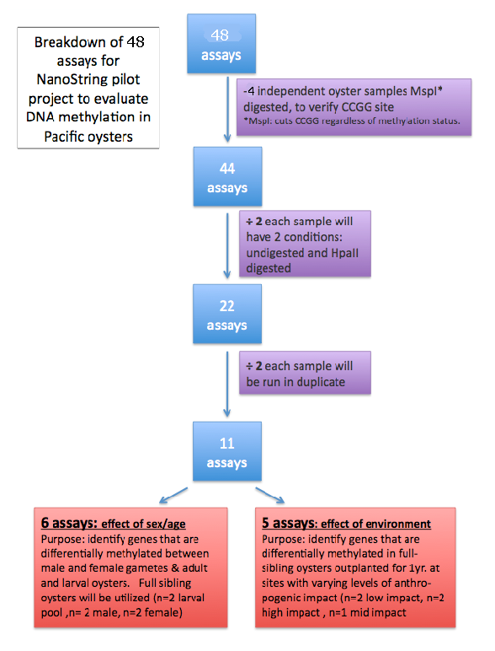

2. NanoString will perform 48 assays in Phase II of this study.

3. The Roberts Lab will provide NanoString with DNA samples required to perform all 48 assays.

4. NanoString will keep the Roberts Lab informed on the schedule of the experiments and will provide all raw and analyzed data.

5. NanoString will set up a meeting with the Roberts Lab to go over the final results of the study.

Roberts Lab Responsibilities

1. Provide samples as detailed in the Research Plan above.

2. Confer with NanoString to provide feedback on the data generated.

3. Allow NanoString use of the data generated in this Project for both written material and oral presentations. Prior to publication of the data, NanoString agrees to restrict presentations to technical discussions about the method and to blind relevant biological data as requested by the Roberts Lab.

4. Recognize NanoString as requested in written materials and presentations describing the data generated in the Project. If a manuscript containing the results is prepared for publication, allow NanoString to review the description of the NanoString technology before submission.

5. At NanoString’s request, a researcher from the Roberts Lab involved in this project will be available to attend a scientific conference to present scientific findings related to this collaboration.

NanoString Technologies Responsibilities

1. Provide all nCounter CodeSets and reagents necessary to run assays described in the Research Plan for the Project.

2. Perform all experiments and data analysis as described in the Research Plan.

3. Confer regularly with the Roberts Lab regarding the status of the Project. Provide all data and data analysis generated in the Project to the Roberts lab. Following NanoString’s approval of data quality, the Roberts Lab may make use of the final data generated in the Project for any purpose.

4. Recognize the Roberts Lab as requested in all written materials and presentations describing the data generated in the Project.

