Research ProjectClaire Ellis

**Cellular response to temperature heat shocks on the Pacific (*C. gigas)* and Olympia (*O. lurida)* oyster**

**Abstract**

**Research objectives**

The Pacific oyster (*Crassostrea gigas)* and Olympia oyster (*Ostrea lurida)* are exposed to environmental variations in Puget Sound, including fluctuating temperatures. Withstanding variable environmental conditions such as temperature changes requires implementation of synchronized responses to cellular stress. We examined expression of chaperonin, a gene involved in maintaining cell viability in response to temperature stress, and was used as a general indicator of stress response between oyster heat shock treatment samples. The chaperonin gene was up regulated as a result of stress response to heat shock. Methylation patterns associated with heat shock treatments in two oyster species were examined. It is expected that methylation patterns will be different between oyster species and among different heat shock temperatures.

**Introduction**

In the Puget Sound, the Pacific oyster *Crassostrea gigas* is exposed to environmental variations including changes in temperature, pH, and oxygen levels, making this organism a key bioindicator species. *C. gigas* lives at a range of tidal heights and routinely encounters large seasonal fluctuations in temperature (Hamdoun et al. 2009). The Olympia oyster (*O. lurida)* is a closely related but much smaller native oyster of the Pacific Northwest. *O. lurida* encounters similar environmental variations as *C. gigas*, however this species is not as commercially important and is therefore understudied. Withstanding variable environmental conditions such as these requires implementation of synchronized responses to cellular stress. However, we lack a full understanding of the mechanisms underlying this response in oysters, or whether these mechanisms are conserved between oyster species (Gavery and Roberts 2010).

Epigenetics, or DNA modifications that change gene expression without altering the underlying nucleotide sequence, includes DNA modifications by methyl groups and histones as well as non-coding RNA activity such as miRNA. The study of epigenetics therefore describes mitotic or meiotic heritable changes in gene function that cannot be explained by changes in the DNA sequence (Bird, Adrian 2002). DNA methylation is one example of an epigenetic mechanism that cells use to control gene expression. DNA methylation involves the addition of a methyl group to a cytosine pyrimidine ring or an adenine purine ring. These methyl groups project into the major groove of DNA and effectively inhibit transcription (Baylin, Stephen B. 2005). However the amount and location of methylation occurring in organisms is extremely diverse and variable among species. It has been previously demonstrated that limited methylation may contribute to increased phenotypic plasticity in highly fluctuating environments (Roberts and Gavery 2012). To examine the effects of environmental variation such as heat shock treatments on *C. gigas* and *O. lurida* we have coupled gene expression analyses with a methylated DNA immunoprecipitation procedure (MeDIP). Following heat shock treatments of *C. gigas* and *O. lurida* we have compared *C. gigas* gene expression levels of a chaperonin protein, a molecular chaperone that provides favorable conditions for the correct folding of proteins under stress. This chaperone, located in the endoplasmic reticulum, plays an important role in maintaining cell viability in response to stress (Meistertzheim et al. 2007). A MeDIP procedure was furthermore performed to compare methylation levels between oyster species and among heat shock temperature treatments. A better understanding of epigenetic modifications and genetic responses as a result of cellular stress in *C. gigas* and *O. lurida* will provide important information on molecular processes activated during environmental fluctuations and allow us to compare cellular responses to stress between oyster species.

**Methods**

Heat shock experiments were performed on *C. gigas* and *O. lurida* at two different temperatures of 35°C and 40°C for one hour each. After treatments were completed, the measurements of individual species were taken by recording the lengths and widths of each oyster. Oysters were shucked, and gill and mantle tissue samples were collected and frozen at -80°C until further processing. RNA extractions were performed on all Pacific oyster heat shock samples using TriReagent (Molecular Research Center, Inc.) and extracted according to the manufacturers protocol. RNA was reversed transcribed to create cDNA using M-MLV Reverse Transcriptase (Promega) according to the manufacturer’s protocol. Gene expression patterns in *C. gigas* tissue were determined using quantitative PCR. Real-time PCR reactions were run on an Opticon 2 Real-Time PCR System. In order to examine *C. gigas* response to heat shock, primers were used for chaperonin-containing TCP1 subunit 7 isoform b (Table 1). Raw fluorescent data was analyzed using Real-Time PCR Miner. R(0) values for chaperonin gene expression levels were calculated using the formula 1/(1+average efficiency)^Ct for each sample. Gene expression levels of chaperonin were normalized to X and t-tests were performed to test for statistical significance.

A methylated DNA immunoprecipitation (MeDIP) procedure will be performed with chaperonin PCR primers to enrich for methylated DNA sequences. Gill tissue from *C. gigas* and *O. lurida* were examined both before and after a temperature shock, using MeDIP to assess differences in methylation patterns. DNA was extracted from gill tissue samples according to the DNAzol potocol and extractions were sheared to the 800-1000bp for MeDIP. 10ug of genomic DNA was subjected to series of three 20-pulse sonications at 20% amplitude (Covaris S-series Sonolab Series v2.54). Fragment size was verified through a 1% agarose gel with approximately 800bp in size. Sheared DNA was resuspended in 350uL of TE and a MeDIP was performed according to the protocol in Guerroro-Bosagna, Carlos et al. 2010. MeDIP DNA was resuspended in 100uL of TE (pH=8.5). The wash samples containing unmethylated DNA were resuspended/combined in a total of 100uL of TE (pH=8.5). Samples were quantified on a nanodrop spectophotometer and gene expression was compared among samples using the chaperonin and other cellular stress response primers for qPCR.

**Results**

Gene expression levels of chaperonin were quantified by comparing the amount of DNA amplified in qPCR between heat shock treatment samples. Using elongation factor 1 alpha (Ef1a) as a normalization gene, the chaperonin gene was up-regulated as a response to stress as the cell attempted to remain viable despite an increase in temperature. Our results indicated an increase in chaperonin gene expression as temperature increased (Figure 1). A significant difference was seen between control Pacific oysters and 40°C heat shock treatments (p-value=0.001). Data exhibited high standard deviation values for each treatment. Gene expression levels of individual samples within each treatment group furthermore exhibited high variability (Figure 2).

Epigenetic mechanisms such as DNA methylation and histone modifications can change genome functions under external influences. A MeDIP procedure was performed to enrich for methylated DNA sequences by isolating methylated DNA fragments through an antibody raised against 5-methylcytosine. I am expecting that increased temperature will change DNA methylation in *C. gigas* and *O. lurida.* I also expect different methylation patterns to be different between *C. gigas* and *O. lurida* due to the differences in size between species.

**Discussion**

Our data exhibited high standard deviation values for each treatment, which could be prevented by incorporating biological replicates into future qPCR analyses. Variability seen among individuals within each treatment may be a result of variability in oyster size. Overall trends indicated increasing gene expression with an increase in temperature in the oyster gill, meaning the chaperonin gene was up regulated during temperature stress. In gill tissue, prolonged heat stress has resulted in the rapid induction of several ATP-generating enzymes including the tricarboxylic acid cycle citrate synthase suggesting that there was a need for rapid aerobic ATP production (Meistertzheim et al. 2007).

These methods furthermore aimed to provide characterization of DNA methylation patterns, as well as describe a portion of the cellular response to heat shock stress with different temperatures. Our results represent the early stages of investigation into the molecular response of oysters to high temperatures, with an emphasis on changes in DNA methylation. If these predictions hold true, we may conclude that the development of stress resistance and certain epigenetic mechanisms may play a role in the survival of oysters under heat shock.

**Figures and Tables**

**Table 1.** Primer sequences and information for chaperonin-containing TCP1 subunit 7 isoform b

|  |  |  |  |  |
| --- | --- | --- | --- | --- |
| Primer Name | Primer Sequence | Amplicon size | G/C content | Melting Temperature (Tm) |
| CE_Gigas_chaperonin_F | TTTGTGTGGGAACCAGCAGT | 167 bp | 50% | 60.03° |
| CE_Gigas_chaperonin_R | TGTCTTCACATGGGCCTTCC | 167 bp | 50% | 59.96° |

**Figure 1.** Average chaperonin gene expression levels for each Pacific oyster treatment.

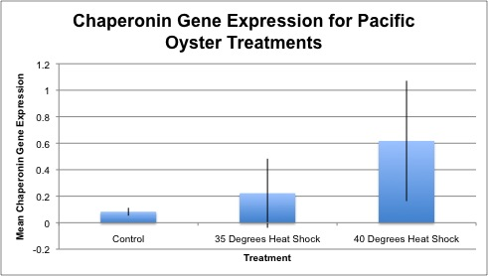

**Figure 2.** Individual gene expression levels of chaperonin protein for individual Pacific oyster samples.

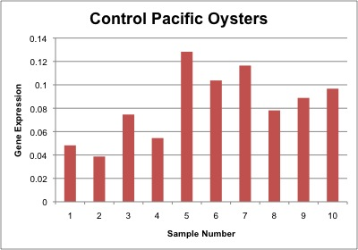

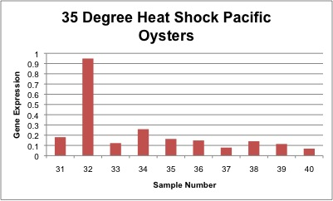

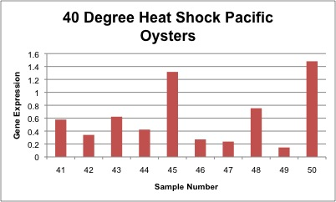

**References**

Baylin, Stephen B. 2005. DNA methylation and gene silencing in cancer. Nature Clinical Practice Oncology, 2: S4-S11.

Bird, Adrian. 2002. DNA methylation patterns and epigenetic memory. Science Review. 210 (4470): 604-610.

Gavery, Mackenzie R. and Roberts, Steven B. 2010. DNA methylation patterns provide insight into epigenetic regulation in the Pacific Oyster (*Crassostrea gigas).* BMC Genomics, 11: 483.

Guerroro-Bosagna, Carlos; Settles, Matthew; Lucker, Ben; and Skinner Michael K. 2010. Epigenetic Transgenerational Actions of Vincloszolin on Promoter Regions of the Sperm Epigenome. Public Library of Science, 5(9): e13100.

Hamdoun, Amro M.; Cheney, Daniel P.; and Cherr, Gary N. 2009. Phenotypic Plasticity of HSP70 and HSP70 Gene Expression in the Pacific Oyster (Crassostrea gigas): Implications for Thermal Limits and Induction of Thermal Tolerance. Biological Bulletin, 205:160-169.

Meistertzheim, Anne-Leila; Tanguy, Arnaud; Moraga, Dario; and Thebault, Marie-Therese. 2007. Identification of differentially expressed genes of the Pacific oyster *Crassostrea gigas* exposed to prolonged thermal stress. Federation of Societies of Biochemistry and Molecular Biology Journal, Volume 274, Issue 24: 6392-6402.

Roberts, Steven B. and Gavery, Mackenzie R. 2012. Is there a relationship between DNA methylation and phenotypic plasticity in invertebrates? Frontiers in Physiology, 2: 116.